MNICS GISS

STANDARD OPERATING GUIDELINES

TABLE OF CONTENTS

CHAPTER 01 - SETUP 2
CHAPTER 02 - GENERATE QR CODES 4
CHAPTER 03 - WWW.MNICS.ORG 5
CHAPTER 04 – NIFC AGOL (RESERVED) 9
CHAPTER 05 - ESRI COLLECTOR (RESERVED) 11
CHAPTER 06 - DNRGPS 12
CHAPTER 07 - DNR GDRS 13
CHAPTER 08 - US NATIONAL GRID 15
CHAPTER 09 - FIMT and FGX TOOLS 16
CHAPTER 10 - NIFC FTP SITE 20
CHAPTER 11 - NATIONAL FIRE ENTERPRISE GEOSPATIAL PORTAL 23
CHAPTER 12 - DEMOBILIZATION 30

CHAPTER 01 - SETUP

BACKGROUND
Each GISS should bring the following equipment to an incident:
- Laptop computer with fully charged batteries
- Mouse and mouse pad
- portable hard drive loaded with the DNR’s GDRS (statewide spatial data library)
- USB drive/s
- DVDs
- Extension cord
- Surge strip

GISS named to teams should bring the following additional equipment (supplied from home unit or MIFC):
- Network Attached Storage device (NAS) loaded with the DNR’s GDRS
- Router
- 5-6 patch cables

The NAS is key to GIS work on an incident, because it is a central repository where all incident products are created from and stored to.

The ITSS will incorporate the NAS into the incident network when they can. This may take a day or more, so the GISS should set up the router and NAS for GIS personnel as soon as arriving at ICP.

STEPS
- Work with SITL to determine a workspace.
- If the ITSS can incorporate the NAS into the network:
  - Use the NASNavigator2 utility in the Buffalo NAS box, or download from www.buffalotech.com
  - Map as the U drive.
  - Wait to begin GIS work until NAS is established.
- If the ITSS cannot incorporate the NAS:
  - Connect router to power source
  - Connect your computer to router with Ethernet cable
  - Set all devices to DHCP (router, Buffalo NAS, laptops, plotter). Troubleshooting tip: When DHCP devices lose power or are restarted they may be granted a new IP, which can break some connections among devices.
  - Connect to the NAS and other devices by name. The NAS Navigator and Printer management utilities make this easier.
  - In Windows Explorer right click COMPUTER and choose Map network drive
      - Map to drive letter U
      - Connect to \\192.168.10.3 <Buffalo NAS name>
      - Check the box Reconnect at login
      - Click FINISH
  - All ArcMap projects should be set to relative paths (device names instead of addresses) before GIS work is started.
  - By default most routers have the following network settings:
    - 192.168.10.1
    - 255.255.255.0
    - 192.168.10.254
  - Set your computer to the router network
- Open computer’s network settings panel.
- Select the internal network card properties.
- Change TCP/IP properties to
  - 192.168.10.2
  - 255.255.255.0
  - 192.168.10.254
- Connect the NAS to the router with Ethernet cable
- Connect the NAS to a power source and power it on
- Use the NASNavigator2 utility in the Buffalo NAS box, or download from www.buffalotech.com , and set NAS device TCP/IP to:
  - 192.168.10.3
  - 255.255.255.0
  - 192.168.10.254

*Note: some Federal computers cannot be on wireless internet and an Ethernet network simultaneously.

CHAPTER 02 - GENERATE QR CODES

BACKGROUND
QR Codes are a fast and efficient method of delivering URL’s and other information by simply having the consumer scan the QR code with a mobile device QR code scanner application. If the QR code references a URL, the user’s mobile device will direct the web browser to the URL site or online data.
Mobile data or Wi-Fi service is required for the user’s device to retrieve QR code content. If data service is poor or non-existent in the incident vicinity, QR codes should not be used.

INSTALLATION
- No installation required. Various QR code generators are available (free) online. Two examples are :

- http://www.qrstuff.com/
- https://www.the-qrcode-generator.com/

USE
- WHEN FIRST ASSIGNED TO AN INCIDENT
  - Find the content you want to code (telephone #, website URL, etc.).
  - Open a free QR code generator online (http://www.qrstuff.com/)
  - Choose the data type your are encoding (step 1 in image below).
  - Paste/enter the content to encode (step 2 in image below). 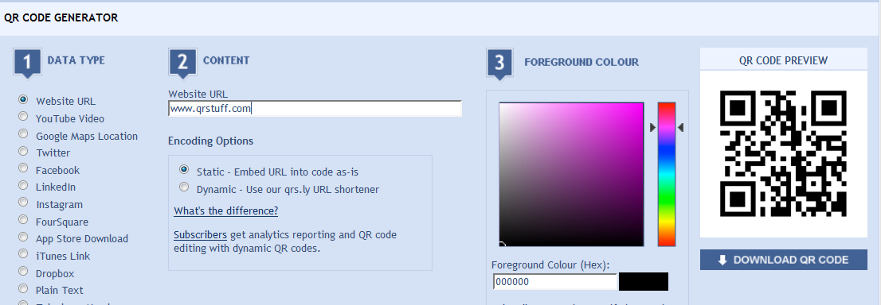
  - Keep the default black foreground color (step 3 in image above).
  - Click Download QR code (far right in image above).
  - Save the file to a location and with a name you can remember and share with others.
  - Open a document, email, text, or map and paste the QR code image into it.

CHAPTER 03 - WWW.MNICS.ORG

BACKGROUND
WordPress is the Open Source application used to build and manage www.mnics.org. It allows collaborative changes to layout, content, and permissions from any internet-enabled device.
The website resides on the same server with the same ISP as it did previously.
The Dashboard is the management backside of the website, and is where pages and content are developed.

ACCESS
There are four levels of permission on the website, as shown in the diagram below:

Some pages and content may be password protected for MNICS member use only. The password is mnallrisk.
All GISSes will be given Editor access to the website. Some versions of Internet Explorer have issues with editing in WordPress, so you may want to use a different browser.
- To request new access go to http://mnics.org/wpress/?page_id=1597
- To change your password, go to the login page and click “Lost your password?”
- To request website changes at any time, click the webmaster link at bottom of any page. The account is monitored daily.

TRAINING

For website tip sheets and user manuals see http://mnics.org/wpress/?page_id=2472

USE

- WHEN FIRST ASSIGNED TO AN INCIDENT
  - Log into www.mnics.org
  - In the dashboard go to PAGES | ALL
  - Search for the incident page
  - Hover over the page name and click Edit
  - Scroll to the bottom of the incident content, then press [Enter] to create an empty line
  - Click the HTML tab
  - Paste the Google Maps HTML embed link into the bottom of the HTML code.
    - Locate the incident within Google Maps <http://maps.google.com/> and move to a zoom scale preferable for the embedded web map.
    - Click the Link, Share, or Embed Map button similar to the example below.
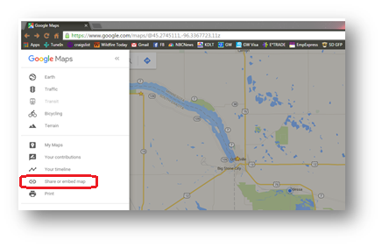
    - Copy the “Paste HTML to embed in website” link
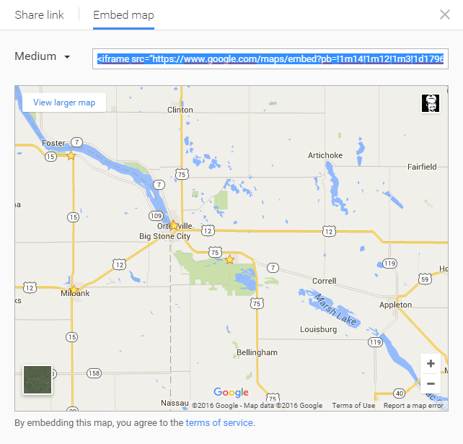
  - Click Preview Changes
  - If the map is acceptable, click Submit.

- WHEN NEW MAP PRODUCTS HAVE BEEN CREATED
  - Log into www.mnics.org
  - In the Dashboard go to MEDIA | ADD NEW
  - Click Browse.
  - Highlight the file to upload (PDF or KMZ, make sure PDFs are optimized and < 2 mb) and click Open.
  - Click Upload.
  - Hover over the uploaded file (top of the list) and click Edit.
  - Add Media-tags (keywords).
  - Copy the file URL.
  - Click Update Media.
  - Go to PAGES | ALL.
  - Search for the incident page
  - Hover over the page name and click Edit.
  - Highlight the words you want to contain the hyperlink, or type new words.
  - Click the Link button.
  - Paste the URL and click Add Link.
  - Add the date and time of posting in parentheses.
  - Click Preview Changes.
  - If the map is acceptable, click Submit.

CHAPTER 04 – NIFC AGOL (RESERVED)

BACKGROUND
NIFC AGOL is in the testing phase during the 2016 fire season. If internet access is limited or not existent at the incident, NIFC AGOL is not an option for use unless data transfers can occur offsite.
ArcGIS Online (AGOL) is an online, collaborative web GIS that allows users to create and share maps and data online. A companion application called Collector for ArcGIS works with AGOL and extends visualization and data collection to the field on mobile devices. A Wildland Fire Information Technology project provided funding for an interagency AGOL account for wildland fire incidents. It is available for any partner agency (federal, state, and local) that participates in wildland fire response. It is available for all IMT levels (1-5) including BAER Teams for use on incidents.
The AGOL account is not just for GIS specialists. Web maps have been created that field personnel and non-technical users can view and edit to enhance their situational awareness. The ability to take maps in the field on mobile devices – with and without cell service – makes this technology very useful for many different incident response positions. The AGOL account is also designed to assist the incident GIS Specialist with becoming more efficient in information collection and dissemination. Work flows and data services have been developed to get the GIS Specialist up and running quickly.

ACCESS
- Prior to the incident, secure access to the NIFC AGOL site at: http://nifc.maps.arcgis.com/home/index.html by clicking on the Request New Account link. Be sure to use an email address that you can access away from agency networks. In limited cases, users may be able to secure new access while on assignment.
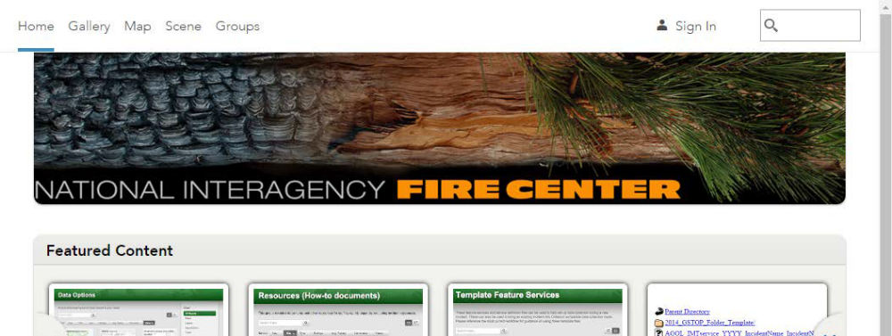

USE
ArcGIS Online is quickly becoming the primary tool used in providing efficient real-time mobile data transfer technology from the fireline to incident command post via ESRI Collector and wireless data networks.
The key to success with AGOL for incident response is preparation and practice. This is a new technology for fire business so training and becoming familiar with the benefits and limitations are critical. There are numerous examples of this technology providing better and more timely intel from the fireline, providing better situational awareness for firefighters, and significantly decreasing paper map production on incidents.
The NIFC AGOL link above has information about training for GIS Specialists and incident personnel. Beyond that, ESRI has extensive training available with information on options available at their website.
- WHEN FIRST ASSIGNED TO AN INCIDENT
  - <in development>

CHAPTER 05 - ESRI COLLECTOR (RESERVED)

BACKGROUND
ESRI Collector installs on mobile devices, such as smartphones and tablets, to view shared maps, collect field data, and wirelessly transfer field data back to a shared national incident feature data service. Data collection can occur in a network connected or unconnected environment after first downloading maps. Digital GIS data forms can be used to standardize field data collection via drop down menus and standard fire mapping symbology.
Other Collector users can utilize this real-time collection of field data to inform their situation awareness and ArcGIS Online users can pull the new data into production maps and live dashboard operations monitoring apps such as Fire EGP.

INSTALLATION
- On your mobile device, download and install Collector from:


USE
- WHEN FIRST ASSIGNED TO AN INCIDENT
  - <in development>

CHAPTER 06 - DNRGPS

BACKGROUND
DNRGPS is the new Open Source version of DNRGarmin. DNRGPS:
- is a “bridge” between GPS and computer
- is a file conversion tool
- can be used with or without a GPS

INSTALLATION
- Download, the executable and accompanying files from http://www.dnr.state.mn.us/mis/gis/dnrgps/dnrgps.html or reference portabledrive\GDRS\apps\pub\us_mn_state_dnr\DNRGPS
- Create a shortcut of DNRGPS.EXE and place on your desktop.

USE
There will always be three steps in using DNRGPS
- Load data into DNRGPS
- Edit records within DNRGPS if necessary
- Save data out of DNRGPS

Note: Loading data into DNRGPS does not delete it from the source.
Note: The File | Load From and File | Save To options reflect what GIS applications are running when DNRGPS is open.

CHAPTER 07 - DNR GDRS

BACKGROUND
The DNR Geospatial Data Resource Site (GDRS) is a folder of spatial data and applications. A full GDRS contains 400+ data layers. The structure of the GDRS is key to its functionality: add or delete items using the GDRS Manager application.
The Quick Layers toolbar is an Add-in for ArcGIS10 that provides quick access to 400+ core state spatial data layers. It includes:
- Quick Layers tool accesses GDRS and WMS data
- Logo tool with most government agency logos.
- Landview tool offers quick coordinate entry, zooming, and conversion.
- DNR Info tool displays info from DNR data for any place clicked on the View
- Export to Image tool exports WYSIWYG to any GPS that can display background maps
- Text Disclaimer adds a standard text disclaimer to the layout
- ArcGIS Manager
  - Change a GDRS Location
  - Refresh MXT
  - Generate GDRS Health Report
  - Install PostGres Drivers
  - Register Bing Maps
- FIM Stand generates a forest inventory stand report and intersecting state ownership

A GDRS is on the NAS drive that each Team GISS carries. It’s a good idea for anyone on emergency response in Minnesota to load a portable hard drive with a GDRS.

INSTALLATION
- USE THE INCIDENT NAS OR A PORTABLE HARD DRIVE WITH A GDRS
- INSTALL THE QUICK LAYERS TOOLBAR ADD-IN
- Connect the hard drive to your computer.
- Open ArcMap and go to Customize | Add-in Manager
- Click the OPTIONS tab
- Click Add Folder
- Highlight portabledrive\GDRS\apps\pub\us_mn_state_dnr\DNRAddIns and click Open
- Turn on the DNR Quick Layers 10 toolbar
- Close the Customize window

USE
- Open ArcMap and use FIMT to create a new Incident Geodatabase.
- Open the Incident Geodatabase.
- Click the Quick Layers button.
- Double-click a layer to add (only one layer can be added at a time).

CREATE

To create a GDRS from a non-networked DNR site download the GDRS Manager from the Minnesota Geospatial Commons, https://gisdata.mn.gov/dataset/gdrsmanager .

Save as to save the .zip file to your computer. Once saved browse to the file, right click and extract all. Inside the gdrsmanager folder, double click on the gdrsmanager.exe and Run.

From the Source GDRS dropdown, select ftp://ftp.gisdata.mn.gov/pub/gdrs. The UN and PW should default to anonymous and anonymous.

From the Destination GDRS dropdown select a location to build or update a GDRS.

If updating a GDRS, select the “Not on Destination” and “Data to be Updated” options.

Select data and apps on the left (source) side and use the green arrows to move them to the right (destination) side.

Always click the DNR logo under the Applications section to ensure the latest Add-Ins for the QuickLayers Toolbar are selected.

Click the Run Complete Update button once data and applications are selected.

CHAPTER 08 - US NATIONAL GRID

BACKGROUND
The US National Grid is a coordinate system based on UTM and using alphanumeric monikers. It may be added to any incident product for reference in areas where all other references (roads, terrain, structures, etc.) are missing. It is most often used for Hurricane and Tornado response.
The US National Grid may also be called the Military Grid Reference System (MRGS). Click here for more information.

INSTALLATION
There is nothing to install in ArcGIS 10.x – the USNG is a default grid component in Layout Views, and/or can be added as a reference layer to Data Views.

USE
CREATE GRATICULE IN LAYOUT VIEW
- Open ArcMap.
- Add a data layer from the GDRS folder, or
  - Right-click the Data Frame name in the Table of Contents and choose Properties.
  - Click the COORDINATE SYSTEM tab.
  - Choose Projected Coordinate System | UTM |NAD 1983 | zone 15N.
- Create a Layout View.
- Right click on the data frame and choose Properties.
- Click the GRIDS tab.
- Click New Grid.
- Choose Graticule.
- Use the wizard to finish creating the graticules.
- Click Style.
- Scroll down and select an MGRS style, then click OK.
- Click OK to close the Properties window.

ADD LAYER IN DATA VIEW
- Open ArcMap.
- Click the drop-down arrow on the Add Data button and choose ArcGIS Online.
- Search for USNG.
- Add the layer.

CHAPTER 09 - FIMT and FGX TOOLS

BACKGROUND
The FIMT toolbar is key to creating standardized data and products on incident. NWCG SOPs mandate use of the toolbar. The next generation of FIMT will be referred to as FGX.

FIMT tools are grouped into hierarchical categories from left to right:
- Utilities dealing with metadata, symbology, labeling, selected features
- Firepolygon and Perimeter feature class tools
- Fireline feature class tools
- Firepoint feature class tools

INSTALLATION
- Download and install FIMT from http://gis.nwcg.gov/links_tools.html.
- In ArcMap10 turn on the Forestry and FIMT symbol sets.

WORKFLOW
- CREATE TRANSPORTATION MAP
  - The first information a GISS usually receives is the location description of a potential fire. The map should include
    - roads
    - man-made structures in the area
    - water sources and known vegetation
    - fire location
- CREATE FIRE POLYGON AND FIRE LINE(S)
- CREATE IAP / BRIEF MAP
- POST FIRE POLYGON TO FTP.NIFC.GOV
- POST OPTIMIZED MAPS TO FTP.NIFC.GOV
- POST KMZ FILE TO WWW.MNICS.ORG
- POST OPTIMIZED PDF MAPS TO WWW.MNICS.ORG
- CREATE AND EDIT ADDITIONAL DATA
  - At the start of each planning cycle, archive all previous data to the history feature dataset.
  - Start with a new map and obtain the latest Fire Polygon, Perimeter Sector, Fire Line and Fire Point data.
  - Make changes to the Perimeter, Labels, Fire Line and any Fire Point information.
- CREATE NEW MAP PRODUCTS
  - Fire Perimeter Map
  - Fire Progression Map
- POST NEW DATA TO FTP.NIFC.GOV
- POST NEW MAPS TO FTP.NIFC.GOV
- POST NEW KMZ FILE TO WWW.MNICS.ORG
- POST NEW MAPS TO WWW.MNICS.ORG
- COMPRESS THE GEODATABASE
- BACK UP WORK FOR THE PLANNING PERIOD
- EXIT ARCMAP

FIMT TIPS
- Adding Reference Data
Load reference data into the map document AFTER creation and loading of an Incident Geodatabase.

- Significant changes to Fireline Polygon
- Delete the fire perimeter from the current Incident feature class.
- Make sure the feature is first copied to the history feature dataset). Then
  - Create a new Firepolygon or Fireline from scratch or
  - Import line or polygon data to form the new perimeter.

- Update Fire Polygon with Line Data
To import lines to update the polygon:
- Load the data into ArcMap.
- Select the polygon to edit, be sure the task is set to Reshape Feature, and target is set to Fire Polygon.
- Use the Selection tools set the selectable layer to Fire Polygon.
- Activate the Sketch Tool.
- Place the cursor over the line from the new theme and right mouse click, choose Replace Sketch.
- If the line is going the same direction as needed to update the polygon, there will be a green point at the beginning and a red point at the end of the line.
  - Complete the line then right-click and choose Finish Sketch).
- If the line is going the opposite direction as needed, hover over the line, right click, and choose Flip.
  - Now complete the reshape.
- Assignment Breaks will be proportionally moved to the new perimeter.
- Split Assignment Lines in the correct locations.
- Assignment Breaks
Work clockwise. There is less changing of the attributes and the program does not become confused.
- More than One Incident Geodatabase Loaded
Use the Switch Incident tool to ensure the correct Incident is being edited.
- History Feature Dataset
Turn the display of the History Feature dataset and its Selection off to prevent accidental editing of historical data.

- Multiple Persons Editing a Personal Geodatabase
Personal Geodatabases disallow more than one application (or person) working at a time. Do one of two things:
- Manage by Feature Class – export a Feature Class to a shapefile. Incorporate the shapefile back into the Geodatabase.
- Edit a copy of the Incident.mdb.
  - Copy Incident data to the History feature dataset.
  - In the copy Incident Geodatabase remove all features from the feature classes being edited.
  - Edit the copy Incident Geodatabase.
  - Load the updates through the same method as above or using ArcCatalog’s Load tool.
- Auto Measure
The Auto Measure tool converts features into an Albers Equal Area Projection, centering the feature in the spatial extent before calculating, producing the smallest possible error. Standard area and length fields are calculated using the projection defined for the Geodatabase.
- Firelines
  - Convert Perimeter Sector layer lines to Firelines because unit assignments exist there.
  - Split any lines to be assigned different Fire Line types.
  - Import additional Firelines.
- Firepoints
- Add all Fire Points into the Incident.
- Use the Populate Fire Point Coordinate Table tool so the table can be loaded onto the Layout.
- General
- Compact the Geodatabase often. The file remembers all additions, modifications, and deletions, so increases in size.
  - In ArcCatalog right click the Geodatabase name and choose Compact Database
- Always archive the Geodatabase and map documents to save time, effort, and embarrassment of losing files.

CHAPTER 10 - NIFC FTP SITE

BACKGROUND

FTP.NIFC.GOV is the national agency/incident personnel clearinghouse for incident data. It is an integral part of the NWCG GISS SOPs for sharing and storing incident data. The NIFC FTP site is intended as a “one stop shop” for agency and incident personnel.

USE

- LOG INTO THE FTP SITE

All portions of the server are password protected. MNICS incidents can log into ftp.nifc.gov/Incident_Specific_Data/Eastern/Minnesota as

Username: Minnesota
Password: MNallri$k

Note: Use an FTP client such as WinSCP, not Windows Explorer or internet browser.

- SET UP AN INCIDENT FILE STRUCTURE ON THE FTP SITE

- At the onset of an incident download a standard GSTOP folder template, or set up a new file structure as follows:

/2016_<Incident Name>
/GIS
/base_data
/dem
/logos
/orthoimagery
/other_maps
/topo_maps
/vector
/documents
/incident_data
/backups
/exports
/Farsite
/final
/gps
/ir
/modified_base_data
/progression
/products
/<yyyymmdd>
/final
/projects
/backups
/tools
/working
/<others as needed>
/ICS_Gen_Staff
/Documents
/IAPs
/others as needed
/Working
/Farsite
/<others as needed>

- MERGE IAP FILES INTO A PDF

- When the IAP has been placed on the <INCIDENTDRIVE>: drive by the Resources Unit leader, merge the following into a PDF file called IncidentName_ IAP.PDF:
- IAP document
- IAP_Briefing_Map
- Fire_Perimeter_ Map
- Fire_Progression_Map
- Transportation_Map

- Save the merged PDF in <IncidentDrive>:\Incident_Name\DOCS\YYYYMMDD\Incident_Name_IAP.pdf (DD is the day of the IAP Operational Period)
- UPLOAD THE MERGED PDF TO THE IAP FOLDER
- Upload <INCIDENTDRIVE>:\Incident_Name\DOCS\YYYYMMDD\Incident_Name_IAP.pdf to ftp://ftp.nifc.gov/Incident_Specific_Data/EASTERN/Minnesota/Incident_Name/IAPs/
- UPLOAD THE MERGED PDF TO THE INCIDENT_NAME FOLDER
- Upload <INCIDENTDRIVE>:\Incident_Name\DOCS\YYYYMMDDDD\Incident_Name_IAP.pdf to ftp.nifc.gov/Incident_Specific_Data/EASTERN/Minnesota/Incident_Name/
- NOTIFY MNICS AND LOCAL AGENCY PERSONNEL
- Send an email with the content below to:
- diane.nygaard@state.mn.us
- MIFCIntell.dnr@state.mn.us
- Local Host Agency Personnel

The IAP and briefing map should be uploaded to the federal FTP server at:
ftp://ftp.nifc.gov/Incident_Specific_Data/EASTERN/Minnesota/Incident_Name/

CHAPTER 11 - NATIONAL FIRE ENTERPRISE GEOSPATIAL PORTAL

BACKGROUND
The Enterprise Geospatial Portal (EGP) was developed to provide geospatial data capabilities between existing applications used to manage data related to wildland fire incidents. The Fire & Aviation Management (FAM) Enterprise Geospatial Portal (EGP) project was undertaken in 2009 to improve the distribution, display, and analysis of geospatial information to support the wildland fire management decision-making process. https://egp.nwcg.gov/

EGP can be thought of as a visualization and analysis tool that spatially enables existing wildland fire information and consolidate disparate geospatial data by organizing it into view states representing various business areas. The EGP provides a geospatial interface which allows users to access wildland fire data layers on a common web-based platform. The EGP allows for a continuous feed of data, and the ability to combine it with other information. Users also have access to data stored in a central data repository which facilitates the exchange of information within and between land management agencies.

There are currently five components within the EGP:
- Fire Globe–2D & 3D situational awareness views using multiple clients
- SituationAnalyst (SA)–tool combining collaborative mapping, geospatial and imagery analysis, with analytical reporting
- Fire EGP Data–static and dynamic data available for use in any of the viewers
- Incident Risk Console (RisC)–analytic dashboard for authorized users which provides data and statistics

The EGP utilizes web-mapping and enterprise database components with up-to-date Google and ESRI technologies. These systems organize data into views of like datasets based on common wildland fire business areas. EGP is currently integrated with and ready to use IRWIN (Integrated Reporting of Wildland Fire Information). In addition, EGP uses data and data services from ICS209, WFDSS (Wildland Fire Decision Support System), WIMS (Weather Information Management System), Predictive Services, Homeland Security, FAA (Federal Aviation Administration), Geomac, among others. More data sources are being added as they become available.

The information within the EGP provides first responders, wildland fire management personnel, dispatchers, and coordination centers with access to up-to-date wildland fire situational data including fire perimeters, weather, fire detections, currently assigned resources, and the availability of other resources. The EGP and its components support the implementation of the cohesive strategy in wildland fire management by bringing data and cooperating partners together.

The main purpose of the EGP is to provide an easy Common Operating Picture (COP) with operational mapping capabilities. MNICS has a generic login for use by members (User: mnics Pwd: mnallrisk). Since you will be adding data and a more advanced user, it is recommended that you request your own login.

WHAT IS IT? WHO SHOULD USE IT?
The SituationAnalyst (SA) application is an incident command and decision maker’s tool for viewing, analyzing, and sharing information on current fires. SituationAnalyst includes all of the Fire EGP content combined with decision support and analysis tools for response planning, fire mapping, risk assessment, and data sharing. Data and analysis generated in SA is shared across the EGP systems.
SA supports operational and tactical decision making in two ways:
- Presenting a common set of viewable and relevant data layers
- Providing a suite of tools that allow users to share, analyze, and act on the data.

REQUIREMENTS
Requirement | Description
Internet Browser | SA is supported in current browsers including Microsoft Internet Explorer, Google Chrome, Mozilla Firefox, and Apple Safari.
Fire EGP Account | Users will need an authorized Fire EGP account with username and password.

FEATURES
The HTML5 version of SituationAnalyst provides a full set of functionality to users on desktop and mobile devices. Functionality is focused on providing detailed incident data, collaborative mapping, geospatial analysis and reporting for mobile as well as desktop users.

VIEWSTATES
Data and tools within SituationAnalyst are grouped into workspaces that are tailored to specific functions across the NWCG.

- Active Incidents
- Intelligence and Resources
- Predictive Services
- Fuels and Planning
- Aviation
- Natural Hazards

PRIMARY MAP VIEW AND MENU
The basic display of SituationAnalyst is a map, with a wide array of data and tools accessible using a menu bar that is located on the left border of the screen. All tools, data, and functions are coordinated using this menu bar which can be hidden or retrieved with the menu icon.

SituationAnalyst: Primary Map View
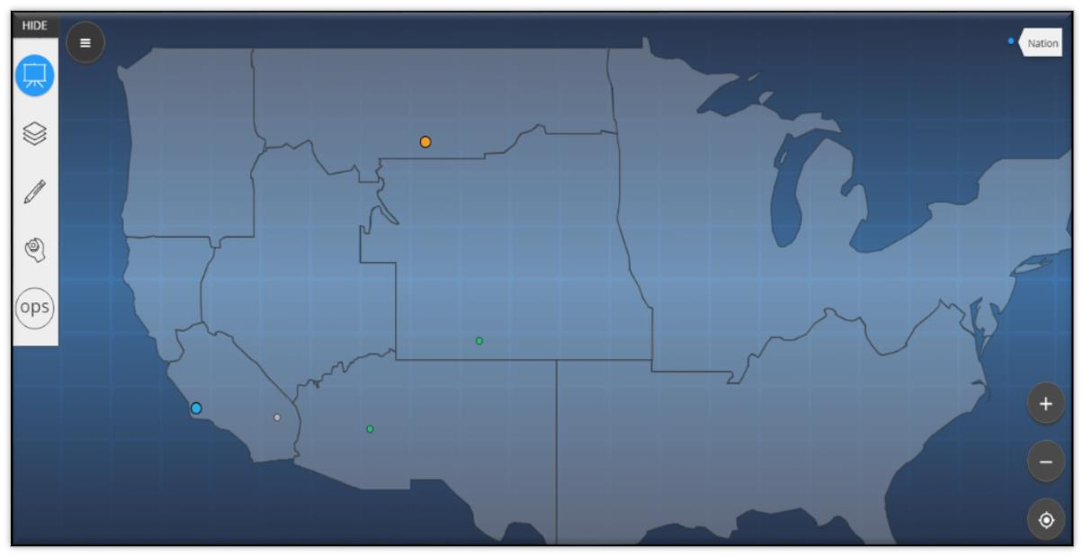
Menu Icon (Hide/Retrieve)

All navigation is performed via the “Main” menu

•
Briefing Tool (currently selected)

•
Manage Layers

•
Edit

Incidents

•
Tools (Measure, Search,
Aircraft Intel, Reports)

•
Workspace Selector/Logout

Incident View is automatically “on” displaying all active incidents entered in the editing tool or from IAP map uploads.

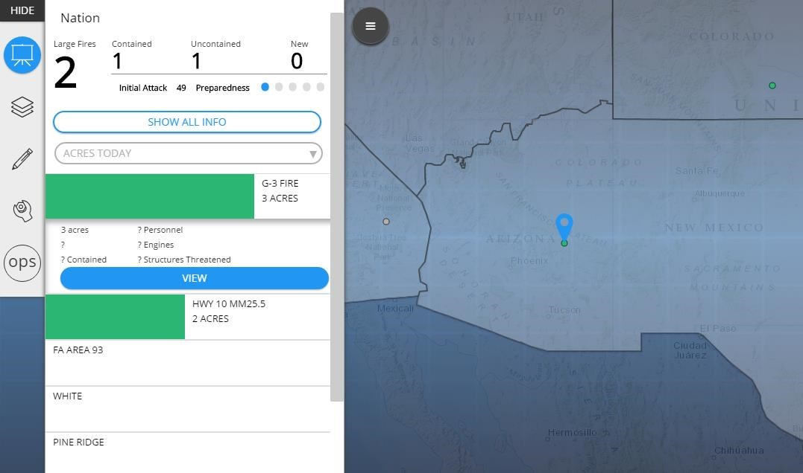

Selecting an incident in the list will pinpoint the location on the map and expand incident data.

MAIN MENU
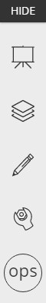

Select to hide or display the menu
Briefing:
displays all incidents, IMSR info
Layers:
turn layers on/off
Add/Edit:
add/update info for an incident
Tools:
measure, search layers, FIMT upload
Me:
identify and change your workspace, user log out

Legends:
available for each active layer

INTERACTING WITH FEATURES ON THE MAP
Tap or (left) click will display detailed data for an incident. Zoom levels affect what is presented on the map layer.

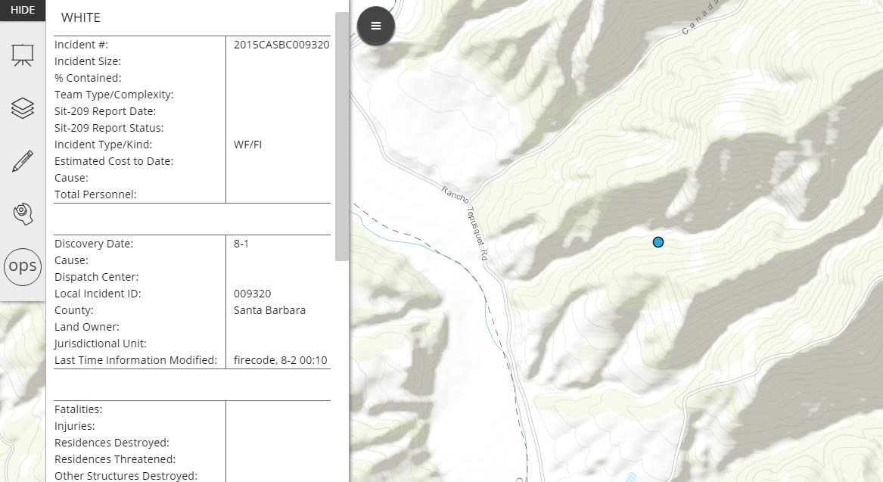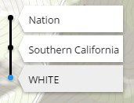

xx

xx

xx

xx

In Briefing, tap or (Left) click on map features for additional data.

To return additional incidents, select the zoom level for the area you want to display.

ADDING DATA TO SITUATIONANALYST
There is generally one way to add data to SituationAnalyst:
Drawing or copying features using the Operational Markup Tool – By using the Operational Markup Tool, users can ‘mark up’ the map with up-to-date fire perimeter and response information. This information is shared with other users of the EGP.

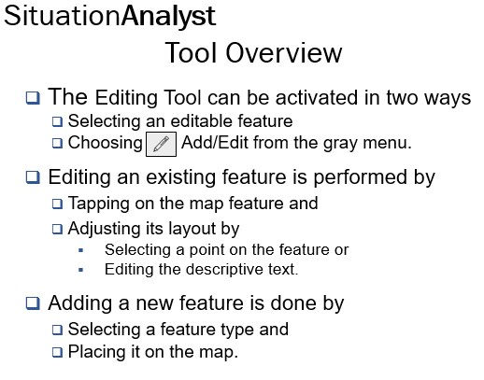
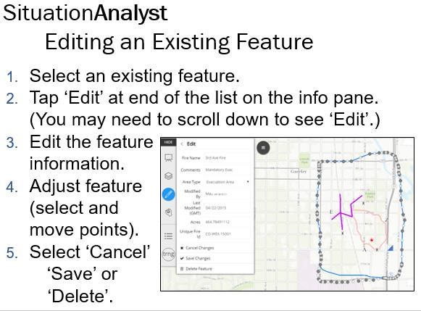

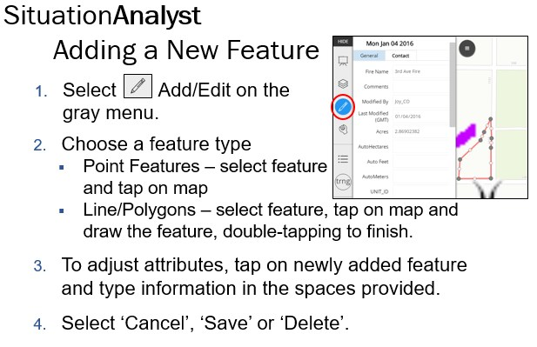

With approved security permission, it is also possible to upload FIMT data to your view of SituationAnalyst.

1. Select the tools  button from the gray menu and then ‘FIMT Uploads’.
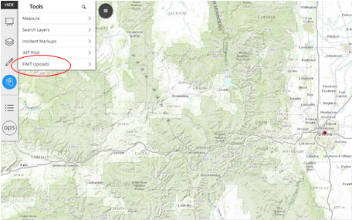

2. Select the ‘Manage Incidents’ button.
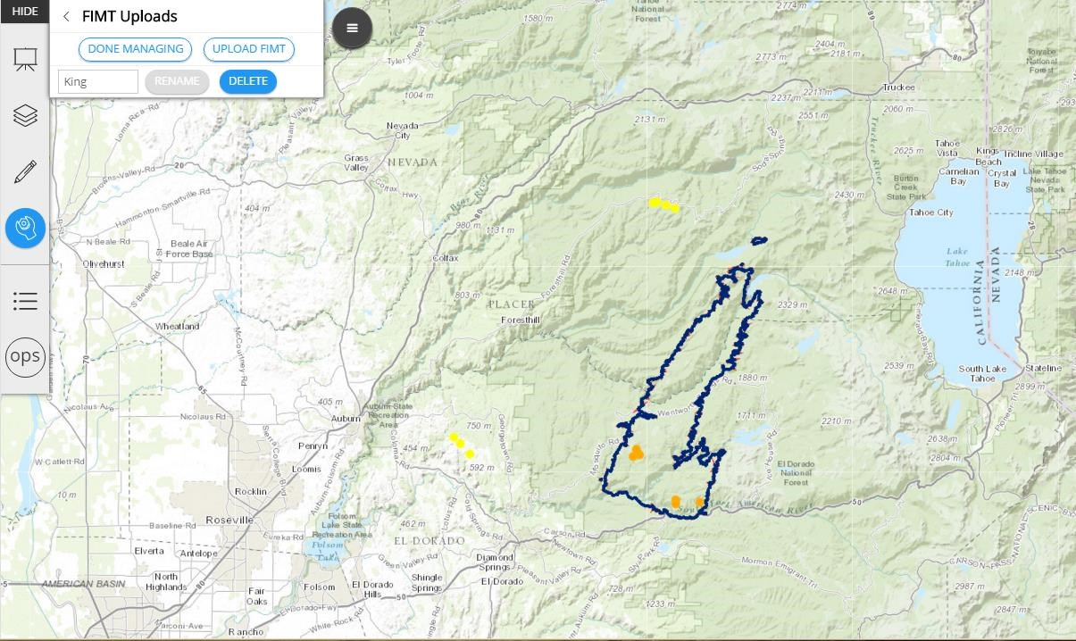

3. Upload the FIMT geodatabase (select 'UPLOAD FIMT' and follow the steps as prompted).

4. To save your updates, tap or touch the 'DONE MANAGING' button.

NOTE: In addition to uploading FIMT files, ‘Manage Incidents’ gives you the chance to rename and/or delete an incident.

CHAPTER 12 - DEMOBILIZATION

BACKGROUND
Before demobilizing from an incident, archive and coordinate data transfer to the host agency. This may be on a DVD or a high-volume jump drive, which is included in the ITSS network kit. Remember: all incident data should be archived and transferred, not just the GIS data.

STEPS
- Back up all incident data on a DVD and send to Tom Kaase at MIFC.
- Back up all incident data to the FTP site. FTP.NIFC.GOV
- Copy all incident data to a DVD or jump drive and transfer to the host agency. Include your contact information.
- Assist the ITSS with teardown of the incident computer equipment. Label the NAS with administrator login and password, if necessary. Also make sure static IP address label on the NAS is still correct.
- Performance Evaluation done by SITL.
- Review GISS Task book and sign off on any tasks for GISS Trainee’s assigned to the incident.

