USDA Forest Service
New Media Resource Guide

Volume 2 - Operator Manual

May 2010

Program Coordinator: Phil Sammon
Technical Coordinator: Donavan Albert

Preface

Since 2009 there have been a number of revisions to various agency and Department policies, guides, and protocols, as well as an increase in the need for information from the basic to the advanced in new media across the Forest Service. To better serve all employees and all levels of leadership, the Office of communication has revised the New Media Guide into a two-volume set. These two volumes are designed to accommodate the spectrum from beginner information, advanced considerations for strategic applications, and hands-on how-to direction for staff to engage and employ approved mew media applications.

As USDA authorization for New Media applications expands, it will be incumbent upon public affairs staff and leadership to apprise forest and unit leadership with the advantages and consideration for these various tools. All new media activities should be planned according to your New Media plan under your organization’s Communications Strategy.

NOTICE

Do not establish any profile or account until you have requested and received permission from USDA through the Forest Service Office of Communication in Washington.

The Department of Agriculture is the final authority to grant account or profile setup on New Media accounts. All Forest Service units will comply with USDA Policy for New Media use and operation.

Introduction

This second volume of the Forest Service New Media Guide is designed to provide the hands-on staff direction and guidance for some basic step-by-step actions to establish, manipulate, and leverage new media accounts and profiles. There are some tips on leveraging your accounts against each other and your forest or unit website, as well as how you can engage partners and cooperators in leveraging your messages, releases, and forest or unit information.

Dynamics of Leveraging

Having your accounts and profiles set up and operational is like having your car running but sitting in park. There are a number of steps that you must take, as well as others you should take and some that you take because you are behind the wheel, before you head out onto the open road. Keep these tips and strategies in mind as you begin to plan your various applications of your new media:

- Everything you post to a new media account should redirect readers or followers to one of your Forest or Unit web pages.
  - News Releases
  - Blog, if you have one
  - Special events page
  - Project pages
  - District information page
  - Recreation
  - Cultural-heritage
  - Conservation education or interpretation
- You need to prepare the material to which you will direct readers/followers ahead of your postings and distribution.
  - News releases have to be posted online before you can tweet the link to followers.
  - Program, project, district, or special event page have to be updated and accurate before you include those links in your news releases and tweets.
- Develop a list of tags, or key search words and phrases for your blog postings and photos.
  - Develop a set of standard tags you use for all of your accounts and profiles, including forest name, local geographic features or recreation and tourism sites, US Forest Service, District names, etc.
  - Use specific project names, timber sale or burn area names, etc.
  - Avoid jargon, acronyms, or any other uncommon words that the public would most likely not use to find your information.
- Your regular web site pages should also contain links to your new media accounts and profiles to encourage people to read or follow your updated news and information
  - Post links to your new media accounts on a page linked to your forest or unit home page.
  - Include a sentence in each press release with links or names of your accounts.
  - Include the links to your accounts in the closing of your email address.
- You need to check the links, and verify the information at the links, before you post it on Twitter or a blog, or in a news release.
  - This highlights the need to complete an accurate move into the Portal structure.
  - It drives people to your web pages and your forest or unit information.
  - It forces departments and resource areas to keep their information current, succinct, and more informative.

Tracking New Media Accounts

Regional offices should maintain a spreadsheet of all existing forest and unit new media accounts. As the authority to establish other accounts on more platforms is granted from USDA, these new accounts will be added to this listing. This will help quantify the region and forest new media efforts and help to identify effective and beneficial initiatives to support future requests for additional accounts. This listing should contain:

- Name of forest/unit, point of contact, phone and email;
- Name of New Media web platform (i.e., Twitter, Blogspot, etc.);
- Account or profile name;
- Synopsis of how this supports and promotes forest or unit communication plan (two or three sentences that tier to the overall communication strategy).

Twitter

Think of Twitter as a man on the street with a bullhorn, or the guy hawking peanuts at a ballgame – he is yelling to get your attention to his product, service, or event. That is the same way you should use Twitter – to drive attention to a press release, event, web information, etc., at a particular website. Twitter is classed as a mini-blog that allows users to share short messages with others who “follow” them on Twitter using their own personal or organizational account. Messages are limited to 140 characters, but can be updated from a computer or a mobile phone using text messaging features.
- Twitter does not have the same level of commitment to time or personnel in the same way that other sites have.
  - It needs to be monitored and used with great regularity, along the order of several times a week to be effective;
  - You can send ‘tweets’ to a broad range of ‘followers’ on the site, or direct messages to specific members;
  - Twitter is a great tool to use to drive traffic to other sites for photos, news releases, trail and recreation conditions, videos, partner or community news with Forest connections, etc.
  - You can set up your Twitter account to be updated from a text-capable cell phone;
- Contact your local media reps, legislative affairs contacts, partners, local community officials and volunteers to find out who already has a Twitter account and get their user name. This will allow you to begin to follow others and establish a following for the Forest Twitter account;
  - Adding followers to your account, and following the tweets from others, is the purpose of Twitter;
  - Building a large base of followers, as well as following others, is what makes Twitter a valuable and interactive communication tool.
- The media, legislative staffs, local residents, employees, partners and volunteers, community and regional environmental and conservation groups, and other federal agencies and Forests are all potential audiences for your tweets.
- Specific steps for setting up your Twitter account:
  - Open up the site at www.twitter.com and click on the “Get Started – Join!” Green box;
  - On the following screen you will need to input your full name (a person) plus a user name, password, and email.
    - Username should be the one you have chosen for all of your profiles or accounts
    - Password should be as difficult as possible, similar to the requirements for an eAuthentication password that includes numbers, symbols and caps. Make sure to write this down.
    - There will also be a reCaptcha security phrase or word that you will have to read and re-type into the designated area, as part of Twitter’s internal security against spamming.
- Once your account is created, you can follow the directions on the various user options to upload photos for your profile, as well as customize the background, and add followers. You will have options to customize your profile under the header “Settings”. The options include;
  - Account, which contains your sign-up info. You can change your contact email in the event someone else takes over the account; a short bio, a place to include a Web site URL (your forest Web site) and the time zone;
  - Password, which allows you to change your password (do this frequently, probably once a month);
  - Devices, where you set up mobile phone access and control of your Twitter account;
  - Notices, where you set the parameters for how you receive various types of replies. You want to read Twitter’s Help Section ;
  - Picture, which allows you to upload a custom picture for your profile;
  - Design, where you select a background, text and color scheme for your profile.
For further guidance about Twitter, access their Help section.

The Twitter Lingo

@ replies: This symbol precedes people’s “handles” or screen names on Twitter when a tweet is directed at them. If you choose to respond to a single comment, start your tweet with @<their twitter name> so they’ll know your reply is meant for them. You can track your own replies in the “@ Replies” tab on your Twitter page, or many of the Twitter clients will do so automatically for you. Note: Your answer can be viewed by everyone who follows your account: you need to identify a significant, compelling or overriding need to address a single follower this way.
RT: Stands for “retweet” and means that the tweet is being reposted from someone else. If I retweet something of yours, that means I’m passing it along for others in my network to see. When you see a tweet that starts with these letters, it means that the person is passing along something that someone else wrote. Many of the third party applications have a one-click button to retweet a post.
Hashtags #: You may often see tweets that end with a hashtag, or a pound sign followed by a term, such as #LongCreek. The purpose is to keep track of tweets that are all part of a single subject, event, or topic. If you head to Twitter Search and type in the full hashtag, you can track all the tweets related to that term. You don’t need to do anything special to use a hashtag, just make one up and tell folks to use it if you want them to tag their tweets for your event or discussion. See the extended information for this in the following section.
link shorteners: Twitter’s 140 character limitation makes posting big links impossible. So you’ll see shortened urls from services like TinyURL and Bit.ly, among others. They take a long URL and condense it down to a short version. Again, clients like TweetDeck and Hootsuite have this built in, but you can use the web versions as well, many of which have a bookmark button you can use in your browser.
DM: This stands for Direct Message and is Twitter’s version of a private message. If you DM someone, you send the message directly to them and no one else can see it. To send one, type the letter D and a space followed by the person’s Twitter name (or use the Direct Messages tab on your profile page). The recipient of the DM needs to be following you for the message to go through. Note: There should be a significant, compelling or overriding need to address a single follower this way. You have no control over your reply to them once you send it. If the information is valuable to one, it should be valuable to all and should be a regular tweet and not a single DM.
Following/Followers: This is the term for other Twitter users who keep up with and receive your tweets when you send them out. They may very well RT your tweets to their friends and followers, expanding the reach and impact of your tweets.
A word of caution about who you follow from your official Twitter account. If you follow some media, or some local groups, or some environmentally active non-profits, but not all, you can be accused of showing a bias, or endorsing some groups over others. Best advice here is to only follow other official federal agencies to remove this appearance and significantly reduce the potential for conflict.
Hashtags
Although not terribly complicated, hashtags have some unwritten rules. The primary one to remember: don’t overuse them. If every one of your tweets IS a hashtag, you dilute the usefulness of them by fragmenting the conversation. In addition, many people will shy away from you because it seems spammy.
Another simple tip: give your hashtag context. Most people won’t actually know what your hashtag means, so give a quick explanation in one of your tweets or, if you’re making a hashtag, make it very apparent what it’s talking about.
Finally, if you’re looking to create a hashtag, be sure that it adds value for yourself and your followers. The best way to utilize them is when you need to organize information. Conferences, major events, and even reminders (i.e. #todo) can help organize specific tweets and make life easier on you and your followers.
Choose a single hashtag early: This may seem simple, but it is vital to get right. Choose a simple hashtag that represents your event or brand. If your subject is the rehabilitation of the Long Creek ATV trail, don’t use #LongCreekATVtrail as your tag. Use #LongCreek or a similar, suitably short name instead.
Remind followers of the hashtag regularly: On your website, on your Twitter feed, at the opening remarks, and throughout the day, make a friendly reminder about your hashtag and that you can track the conversation through it.

Monitoring and Analytical Tools

TweetDeck

TweetDeck is the leading browser for the real-time and social web, allowing users to connect with Twitter, Facebook, LinkedIn and MySpace.
TweetDeck shows you everything you want to see at once for better timeliness and organization.
TweetDeck is a real-time application that allows users to monitor that information in a single concise view. TweetDeck currently integrates services from Twitter, Twitscoop, 12seconds, Stocktwits and now Facebook and MySpace.
But at the heart of TweetDeck is its ability to group people together and search across the twittersphere. Grouping friends or work colleagues separately means you have a window on all aspects of your twitter life. Searching across the twittersphere means you can monitor any subject within Twitter. These additional columns automatically update so providing the user with a very effective dashboard of realtime information.
Retweet Twitter style - or your style - it’s up to you!
Perform both new Twitter and traditional retweets with ease. All retweets are now visible in your TweetDeck columns, and if it was sent using the Twitter method, you can easily see from the avatar the person who retweeted, as well as the original sender.
Manage your conversations
TweetDeck makes it easy to follow your conversations, easily reply or direct message people right from their tweets. See exactly what your friends are twittering on about and join the conversation in just a few clicks.
See Who is Following You
Do you find that your Twitter followers change daily? For an instant check, you can add a special separate 'New Followers' column in TweetDeck. And, of course, there are options to follow them too if you choose.
Click on the New Followers icon in the Twitter menu, to load this into your TweetDeck.
Manage multiple Twitter accounts easily
Manage all your Twitter accounts from TweetDeck without switching between them. View all of the information you need from all of your account at once. And cross-post tweets to different accounts at the touch of a button. This feature is advantageous if you have separate Twitter accounts for districts or programs on your forest or unit.
Stay updated with Real-Time Search
Create search columns which auto update every time someone in the Twitterverse mentions the search term.
You can create search columns for anything you want to stay informed about: you, your brand, your competitors’ brands, hashtags you’re interested in or anything you’re passionate about.
And now you can edit your search terms directly from the column. So you could have a column just dedicated to quick searches. This is handy if you want to monitor keywords surrounding your incident and how individuals are using or redistributing your messages.

Twitter-specific Analysis
One of the important aspects of a Social Media presence is your ability to measure its effectiveness in achieving your end goal. While many people focus on the number of follwoers they have, a more effective and useful measure would be the quality of your followersthat is more important. Sending dynamic messages (with links to articles, photos, etc.) with good content will cause engaged followers to retweet your messages, further engaging their folloswers to your messages and information. There is far more value in this types of activity than just sending non-dynamic propaganda.
This becomes evident when you begin looking at these three free analytic tools that will help you determine the effectiveness of your Agency on Twitter.

TweetStats http://tweetstats.com
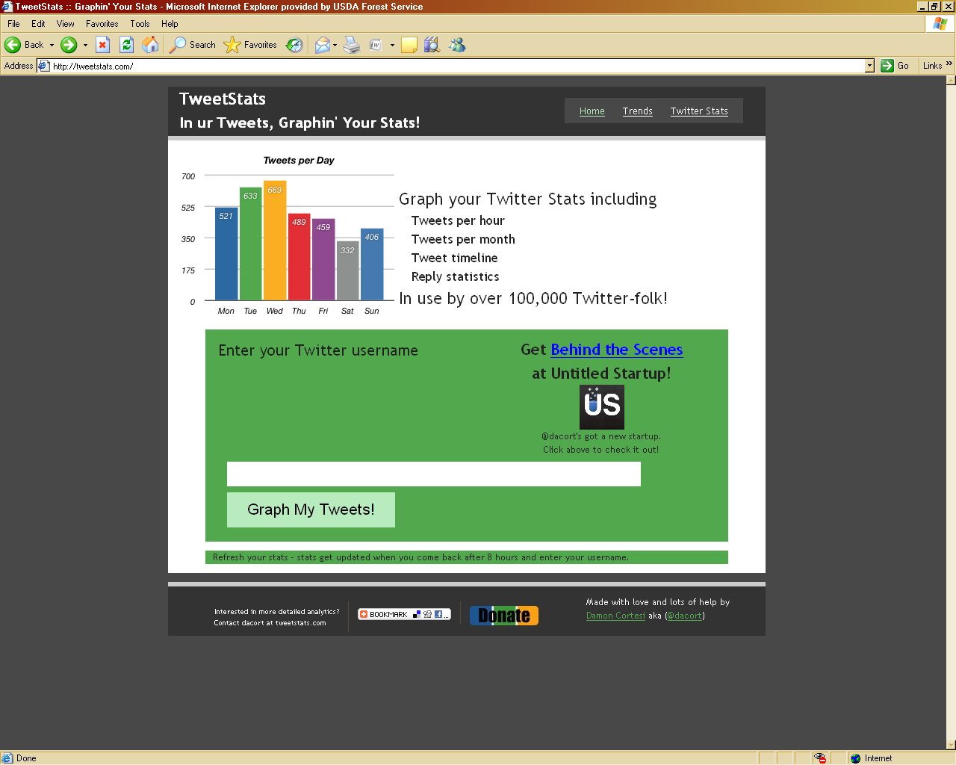
This is a very simple tool that measures the number of tweets your account sends out on a monthly basis, as well as the density of messages and their times sent over the course of a week. The tool also gives you insight into the top ten users you have retweeted and who have “@” messaged you. While the analytics aren’t deep, this is a great little tool to measure just how much your Agency uses Twitter, and to be able to quickly spot any gaping holes in your Twitter messaging approach. This application runs slowly if you have a lot of followers, however.

Twitalyzer http://twitalyzer.com
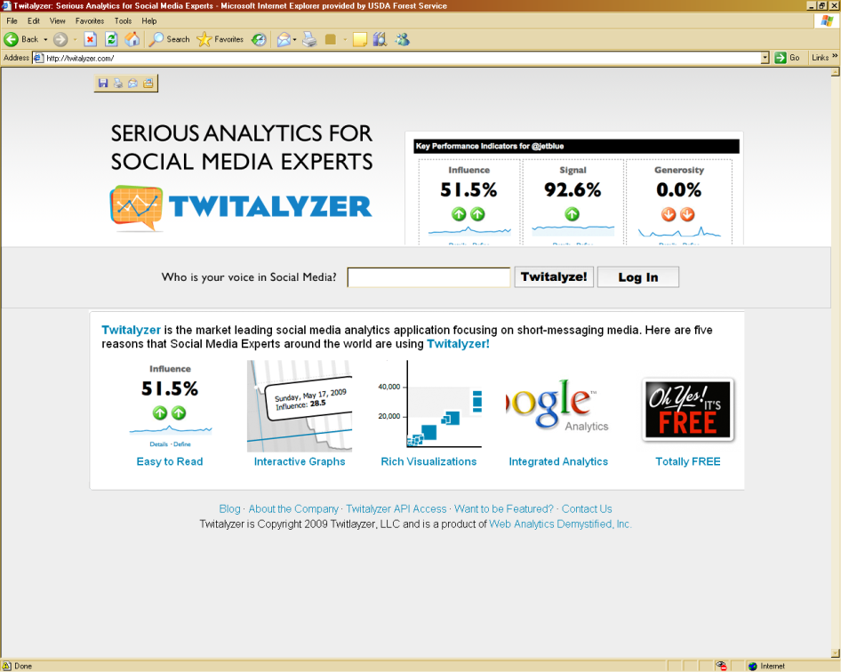
This is a more advanced tool for analyzing your effectiveness. Twitalyzer breaks your statistics down into 5 groups: Influence, Signal, Generosity, Velocity, and Clout. Twitalyzer breaks down your activity on Twitter, coupled with the activity of your followers, and is able to develop a better picture of your account than just counting the number of followers you have. Twitalyzer excels as a tool used over time. You should analyze your Twitter account once a week on a set day, and after a month of analytics has been recorded you can look at the changes from a time based perspective.

Twitter Analyzer http://twitteranalyzer.com
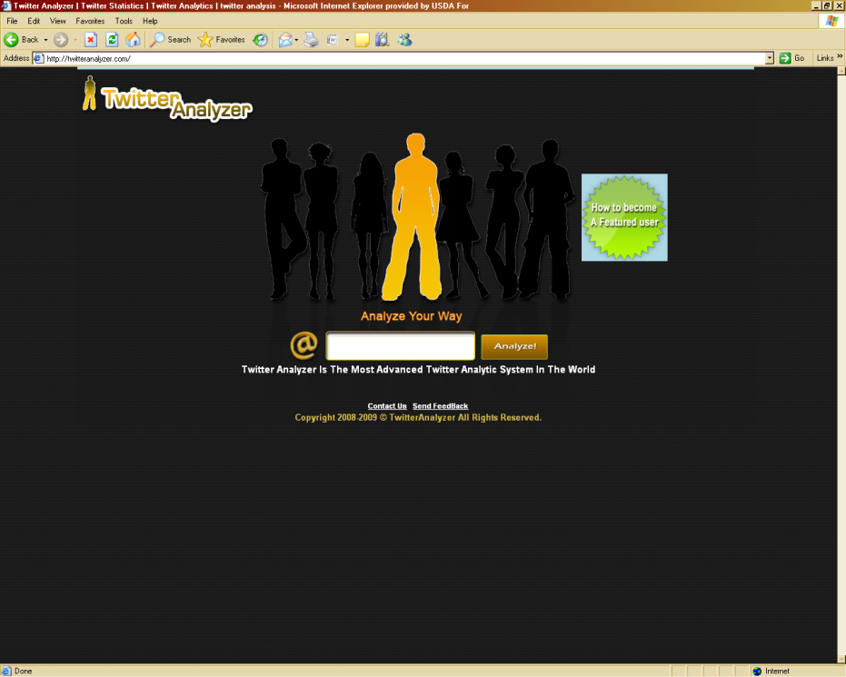
This is by far the most colorful user interface of the bunch. Twitter Analyzer provides you with a slew of statistics including your Popularity and Reach. However the real hidden jewel of the service is showing you the number of your followers who were recently online using Twitter. This is a very important statistic to know and understand, because the number of your overall followers is less important than the number of engaged followers.

Google Applications

Google offers a number of options, applications, and features that can be used to bolster the effectiveness of your new media activities. There are some features that will help you track the reach and re-distribution of your news releases and key messages in your blogs, tweets, etc., as well. You can also use some of their features for collaborative planning and document construction using Google Docs and other shared options that are accessible by cooperators and other partners. All you need is a Google account to get started.

Google Alerts

Google Alerts are emails automatically sent to you when there are new Google results for your search terms. You can also choose to have your alerts delivered via RSS (really simple syndication) feed to the feed ‘reader’ of your choice (e.g., Google Reader or add the feed to your iGoogle page). We currently offer alerts with results from News, Web, Blogs, Video and Groups. Google Alerts currently offers six variations of alerts - 'News', 'Web', 'Blogs', 'Comprehensive', 'Video' and 'Groups'.
•
A 'News' alert is an email aggregate of the latest news articles that contain the search terms of your choice and appear in the top ten results of your Google News search.
•
A 'Web' alert is an email aggregate of the latest web pages that contain the search terms of your choice and appear in the top twenty results of your Google Web search.
•
A 'Blogs' alert is an email aggregate of the latest blog posts that contain the search terms of your choice and appear in the top ten results of your Google Blog search.
•
A 'Video' alert is an email aggregate of the latest videos that contain the search terms of your choice and appear in the top ten results of your Google Video search.

A 'Comprehensive' alert is an aggregate of the latest results from multiple sources (News, Web and Blogs) into a single email to provide maximum coverage on the topic of your choice.

Google Reader (http://www.google.com/reader)

Stay up to date Google Reader constantly checks your favorite news sites and blogs for new content. Whether a site updates daily or monthly, you can be sure that you won't miss a thing.
Simplify your reading experience Google Reader shows you all of your favorite sites in one convenient place. It's like a personalized inbox for the entire web.

Discover new content Millions of sites publish feeds with their latest updates, and our integrated feed search makes it easy to find new content that interests you.

Google News

Google News is a computer-generated news site that aggregates headlines from news sources worldwide, and groups similar stories together and displays them according to each reader's personalized interests. You establish your own criteria from your Google Account preferences.

Blogs and Applications

Blogging and blogs (short for web log) is a Web-based diary or logbook that many individuals use to catalog their lives, trips, work, projects, etc., aimed at a specific group of potential followers.
The proliferation of blog platforms, types, and availability make it essentially difficult to provide a how-to guide for all of them. The best advice you can get is to talk to other forest or Region PAOs and web masters to get opinion on the features, advantages, and benefits of the different blog platforms available. The best approach is to determine the ultimate use for your blog and the primary audience you wish to reach before you identify and select a blog platform. Once you have made your selection, use that platform’s Help section or search online for tips and options that you can apply to enhance your blog’s appearance and clarity.

Here are some general information and considerations for blogs that may be useful.

- Blogging is a means of communicating actions, strategies, information, and opportunities to internal and external audiences in a conversational and engaging social environment.
- Blogs are social by nature, whether they are open to the public as a whole or limited to only a small, select group (i.e., internal employee blog). They can be used to:
  - Provide a ‘face’ to the organization
  - Engage various publics or audiences directly
  - Discuss and explain issues or situations at length
  - Introduce a platform to solicit public responses to an issue, event, or project;
- Blogging should not be done simply to get into the act like everyone else.
  - There can be serious repercussions to having information posted to public-facing social sites that become permanent.
  - There are legal implications that must be considered, as well as time and funding considerations for developing, maintaining, monitoring, and responding to social media demands.
- Someone must actually draft and finalize everything that goes into a blog.
  - By its nature as an electronic diary or log book, it needs to be written a few times a week, no fewer than weekly;
  - It needs to have a distinct and recognizable style or persona, that will become the forest persona within that social media
  - You need to be able to develop the content so that you can leverage it against current issues, projects, situations, events or controversies to make it timely and important.
- Once you start a blog, it requires continuous feeding, care, and attention.
  - Not only in writing each installment, but in answering questions and addressing concerns;
  - You cannot leave issues hanging – the public will call you on it.
  - Be prepared for that level of weekly commitment to an external blog before you even set up the account.
- Blogs can be supported on a number of social networking platforms. Many of the social sites include a blog space as part of your profile, account, or membership.

YouTube Submissions

As of the date of this Guide, the USDA Office of Communications, maintains the only official account to which all agencies and components may post official Youtube videos. Local units are not authorized to establish or maintain YouTube accounts. The process for submitting your videos to tehUSDA Channel are outlined below.

Process Overview

- Forest or Unit
  - Complete the YouTube Video Submission Form from New Media Guide.
  - Submit through Region PAO for review/approval.
  - feedback to WO OC Coordinator for responses or follow-up as necessary.
- Regional Office
  - Review and approve submission.
  - Post approved form and video file to ftp://ftp2.fs.fed.us/incoming/dwalbert/
  - Notify WO OC New Media Coordinator (Phil Sammon) and Visual Information Products contact (Karl Perry) once files are posted.
  - Notify forest/unit of action.
- WO Coordination
  - Receive and review submission form and video file.
  - Notify VIP.
  - VIP will review for technical criteria and return approved form/package to OC.
  - New Media Coordinator forward video file to USDA.
  - Notify the Region and forest when forwarded and posted to Youtube.
Video Encoding Specifications

Below is a list the Forest Service’s encoding requirements for video that will be delivered on the Web, either internal or public-facing websites. These requirements are for video in 16:9 format.

 |  |  |  |  |  |  |  |  | 5 Minute Video
Type | File Format | Video Codec | Audio Codec | Width | Height | Video Bit Rate | Frame Rate | Audio Bit Rate | Target File Size
Flash | .flv | On2 VP6 | MPEG Layer III (MP3) | 768 px | 432 px | 1024 kbps | 30 fps | 96 kbps | 44 mb
Windows Media | .wmv | WMV9 | WMA9.2 | 768 px | 432 px | 1024 kbps | 30 fps | 96 kbps | 42 mb
MPEG1 | .mpg | MC | MC | 512 px | 288 px | 1.24 Mbps | 30 fps | 96 kbps | 52 mb
Notes about each file type requested:

1) .flv - the primary video playback file on the Web and used in a progressive download manner.
2) .wmv – a download alternative for users that have satellite or other slow connections where the .flv progressive download approach does not work well (very small number of users).
3) .mpg - the file that we send to CaptionMax for captioning services. In return they send us a .xml file based on an agreed-to specification.

Things to Check -

1) Audio Levels: Please make sure audio levels are adjusted and set for “normal” or consistent levels as other video on the Internet (comparable to current YouTube video).
2) Starting & Ending: Prior to encoding the video, make sure that any prolonged black space and delays are cut off the beginning and end of each video clip. A standard “fade-in” from black and “fade-out” to black are desired in the beginning and ending of the video clip as well.

Comments/Questions: contact Donavan W. Albert at (202) 205-1407 or dalbert@fs.fed.us

Sources:
http://www.adobe.com/devnet/flash/apps/flv_bitrate_calculator/index.html
http://www.adobe.com/devnet/flash/apps/flv_bitrate_calculator/video_sizes.html

YouTube:
http://www.google.com/support/youtube/bin/answer.py?answer=132460

Forest PAO

  - When package is OK’d by Regional Office Send to OC Youtube ftp site
    - include checklist, written story, transcripts if available, and how you achieved 508 compliance
  - Notify the WO OC Coordinator
  - Submit to appropriate partners or groups as relevant for cross-promotion and posting
  - Promote locally when video is posted to Youtube channel
Monitor Forest or Unit video postings for comments, questions, etc. and provide

USDA Forest Service
YouTube Production Submission Checklist
DATE |  |  |  |  | Unit |  |  |  |  |  | Region
Project Title |  |  |  |  |  |  |  |  |  |  |  | Length
Format |  |  |  |  |  |  |  | Encoding |  |  | Open Captioned |  |  |  |  |  | YES NO
Contact |  |  |  |  |  |  |  |  | Email
Phone |  |  |  |  |  |  |  | Cell |  |  |  | Fax
Brief Description of video
Proposed audience
Describe ARRA Project Connection if applicable
Partner Involvement
Requestor signature |  |  |  |  |  |  |  |  |  |  |  |  | Date
Forest supervisor signature |  |  |  |  |  |  |  |  |  |  |  |  | Date
Regional Office Approval |  |  |  |  |  |  |  |  |  |  |  |  | Date
WO New Media |  |  |  |  |  |  |  |  |  |  |  |  | Date
WO Visual Information |  |  |  |  |  |  |  |  |  |  |  |  | Date
Date forwarded to USDA |  |  |  |  |  |  |  |  |  |  |  |  | Date
Notify Originator |  |  |  |  |  |  |  |  |  |  |  |  | Date
Notify Regional Office |  |  |  |  |  |  |  |  |  |  |  |  | Date

Summary

This living document is best improved by the discoveries made at the field level. The how-to for these new media platforms will change over time as the applications improve or offer new features or options. You are strongly advised to stay close to your accounts and the technology that supports them to take advantage of emerging applications and changes that could impact your content and presentation.

Disclaimers and Notices

Legally we must provide the disclaimers or a link to them from any of the Web pages we establish as an agency of the US government. While you may not be able to place this information on a particular new media account or profile, you need to include a link to this information somehow, or at least a statement that these disclaimers are accessible from your Forest Internet page.

The information below is taken directly from the US Forest Service Internet page for Disclaimers and Notices.

Disclaimer for External Links
The appearance of external hyperlinks does not constitute endorsement by the Department of Agriculture of the linked Web sites, or the information, products or services contained therein. Unless otherwise specified, the Department does not exercise any editorial control over the information you may find at these locations. All links are provided with the intent of meeting the mission of the Department and the Forest Service Web site. Please let us know about existing external links you believe are inappropriate and about specific additional external links you believe ought to be included.

Disclaimer of Liability
With respect to documents available from this server, neither the United States Government nor any of its employees, makes any warranty, express or implied, including the warranties of merchantability and fitness for a particular purpose, or assumes any legal liability or responsibility for the accuracy, completeness, or usefulness of any information, apparatus, product, or process disclosed, or represents that its use would not infringe privately owned rights.

Nondiscrimination Notice
The U.S. Department of Agriculture (USDA) prohibits discrimination in all its programs and activities on the basis of race, color, national origin, age, disability, and where applicable, sex, marital status, familial status, parental status, religion, sexual orientation, genetic information, political beliefs, reprisal, or because all or a part of an individual's income is derived from any public assistance program. (Not all prohibited bases apply to all programs.) Persons with disabilities who require alternative means for communication of program information (Braille, large print, audiotape, etc.) should contact USDA's TARGET Center at (202) 720-2600 (voice and TDD). To file a complaint of discrimination write to USDA, Director, Office of Civil Rights, 1400 Independence Avenue, S.W., Washington, D.C. 20250-9410 or call (800) 795-3272 (voice) or (202) 720-6382 (TDD). USDA is an equal opportunity provider and employer.
Updated: 4 May 2007

Equal Employment Opportunity Data Posted Pursuant to the No Fear Act
This is the reporting page for the Notification and Federal Employee Antidiscrimination and Retaliation Act of 2002 (NO FEAR Act), Public Law 107-174.

Disclaimer of Non-endorsement
Reference herein to any specific commercial products, process, or service by trade name, trademark, manufacturer, or otherwise, does not necessarily constitute or imply its endorsement, recommendation, or favoring by the United States Government. The views and opinions of authors expressed herein do not necessarily state or reflect those of the United States Government, and shall not be used for advertising or product endorsement purposes.

Security Notice
Information presented on the Forest Service Web site is considered public information and may be distributed or copied. Use of appropriate byline/photo/image credits is requested.
- For site security purposes and to ensure that this service remains available to all users, this government computer system employs software programs to monitor network traffic to identify unauthorized attempts to upload or change information, or otherwise cause damage.
- Except for authorized law enforcement investigations, no other attempts are made to identify individual users or their usage habits. Raw data logs are used for no other purposes and are scheduled for regular destruction in accordance with National Archives and Records Administration General Schedule 20.
- Unauthorized attempts to upload information or change information on this service are strictly prohibited and may be punishable under the Computer Fraud and Abuse Act of 1986 and the National Information Infrastructure Protection Act.

