MINNESOTA AERIAL FIREFIGHTING ASSETS 2015
Shaded areas of the map are further than 5 miles from a water source that is suitable for scooping scoopers.

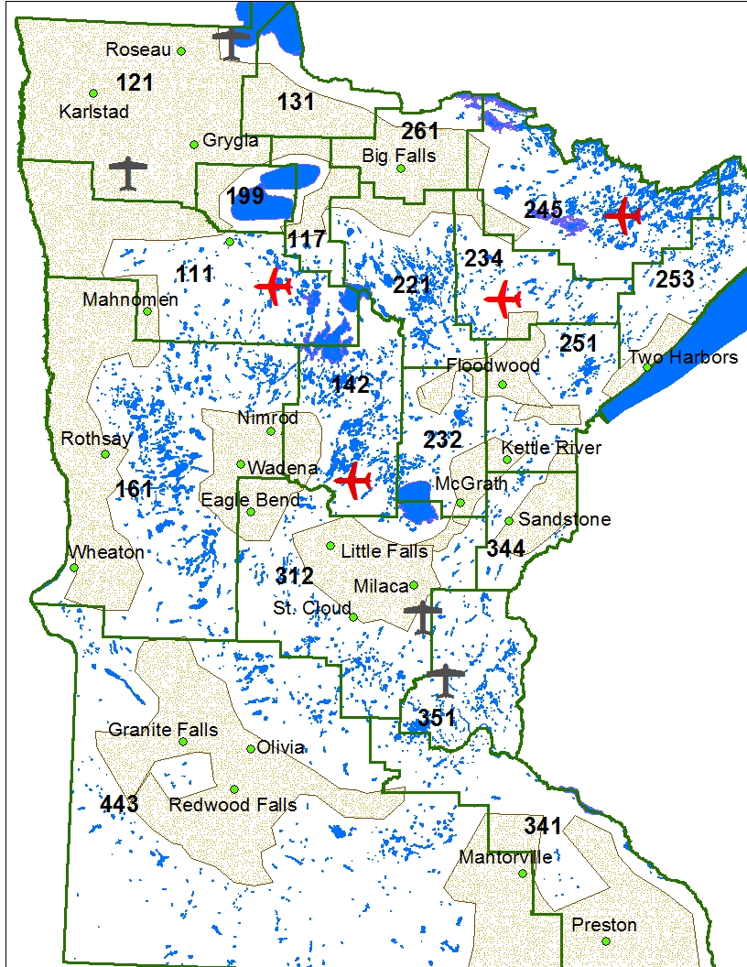
- Aircraft are available. If you think you need them, order them based on weather, fuels, values threatened and potential for large fire growth.
- Aircraft are most effective when ordered in the early stages of the fire.
- Don’t be concerned if aircraft are on another fire, your fire may be the higher priority or aircraft from another source or location could be available.
- If you order aircraft and it turns out they are not needed, that’s OK – they can be turned around.
- Questions about costs and billing can be dealt with after the fire is extinguished.

2015 Aviation Assets

MN DNR
- 4-Fire Boss’
- 2-SEATs
- 8-Type III Helicopters
- 1 to 4- ATGS platforms
USFS
- 1-Type III Helicopter
- 1-Type I Helicopter
- 3 Beavers
- Possible CL-415
Red Lake Agency / BIA
- 1-Type III Helicopter
- Possible CL-415 or SEATs

Fire Boss’ dispatched in pairs will normally be more effective.
When tankers are requested and ISI is >10, multiple drops and/or multiple aircraft are required on over 90% of fires.
Legend
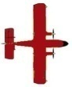 | Permanent Tanker Bases | 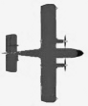 | Temporary Tanker Bases

