Aerial Fire Suppression Aircraft in Minnesota
Water Scoopers

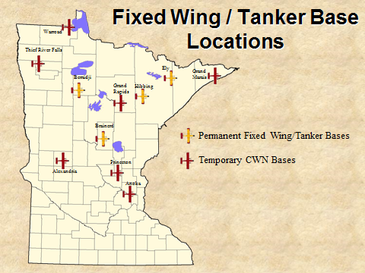 | Fire Boss | CL-215 | CL-415
 | 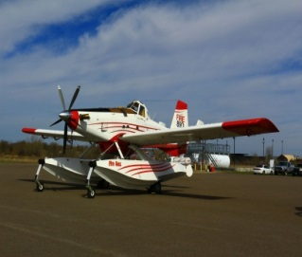 | 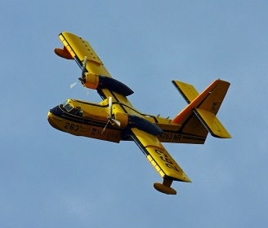 | 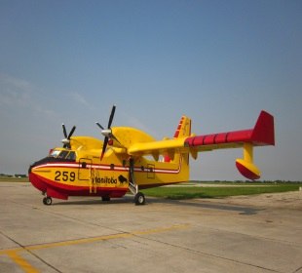
Water Dropping Capacity | 799 Gal | 1,400 Gal | 1,600 Gal
Foam Capabilities | 24 loads – Maximum | 20 Loads | N/A (Current Contract)
Gel Capabilities | Load at Tanker Base | N/A | N/A
Retardant Capabilities | Load at Tanker Base | N/A | N/A
Drop Height | 60-100 ft. above canopy | 100-200’ above Canopy | 100-200’ above Canopy
Load Release | Two Clamshell Doors – Computer Controlled Constant Flow – Salvo, String, or Split Drops – Coverage Level 1-6 | Two Doors –Computer Controlled, Single Operation, Sequence or Salvo | Four Doors – Computer Controlled, Single Operation, Sequence or Salvo
Type of Fuel | Jet A | 100LL | Jet A
Fuel Burn/hour | 600 lbs/90 gal | 1000lbs/225 gal. | 1500lbs/350 gal.
Min Runway Length | 3,000 gravel | 5,000 feet | 3,500 feet
Water Scooping Distance (Touch down to lift off) | 2,000 feet | 2,000 feet | 2,000 feet
Total Pickup distance to clear 50 foot obstacle | 5,668 feet | 5,280 feet | 4,400 feet
Min. Scooping Water Depth | 4 ft. | 8 ft | 8 ft
Headwind Limitations | 40 mph | None | None
Crosswind | 20 knots | 22 knots | 22 knots
Fuel Cycle | 3 hours | 4 hours | 4 hours
Normal Cruise Speed | 140 knots | 150 knots | 170 knots
Max. Cruise Speed | 155 knots | 164 knots | 187 knots

Tanker Operations Safety
Tanker operations are potentially dangerous. The entire load can be released in seconds. From drop heights of 100-200 feet, this force can have a devastating effect on tree crowns and shallow rooted tree species. It is essential that all line personnel stay clear of the drop zones.
Buffers around the drop zone must be maintained to provide a safe working environment for ground personnel.
These minimum standards should be followed:
- 200’ laterally for personnel & equipment
- 300’ in front of or behind canopied equipment
- 500’ in front of or behind unprotected personnel

