Aerial Fire Suppression Aircraft in Minnesota
Land-Based Tankers

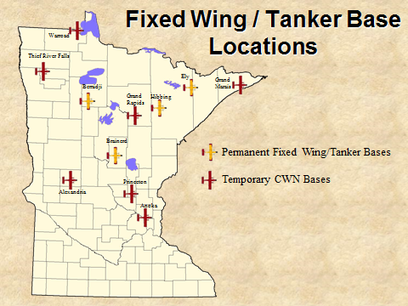 | SEAT | Large Air Tankers | Very Large Air Tankers (VLAT)
 | 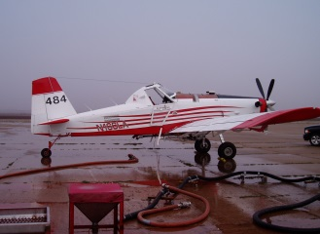 | 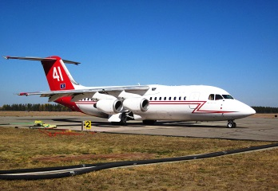 | 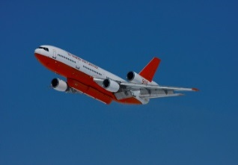
Water Dropping Capacity (Gals) | 799 | Type I – > 3,000  Type II – 1,800-2,999  Type III – 800-1,799 | 10,000+ Gallons
Gel Capabilities | Load at Tanker Base | Load at Tanker Base | Load at Tanker Base
Retardant Capabilities | Load at Tanker Base | Load at Tanker Base | Load at Tanker Base
Drop Height | 60-100 ft. above canopy | 100-200’ above Canopy | 100-200’ above Canopy
Load Release | Two Clamshell Doors – Computer Controlled Constant Flow – Salvo, String, or Split Drops – Coverage Level 1-6 | Four Doors –Computer Controlled, Sequence or Salvo  Coverage Level 1-6 | Four Doors – Computer Controlled, Sequence or Salvo  Coverage Level 1-6
Type of Fuel | Jet A | Jet A | Jet A
Fuel Burn/hour | 600 lbs/90 gal | 6700 lbs/1000 gal. | 18,090 lbs/2700 gal.
Min Runway Length | 3,000 gravel | 5,000 feet | 6,000 feet
Headwind Limitations | 40 mph | None | None
Crosswind | 20 knots | 22 knots | 22 knots
Fuel Cycle | 3 hours | 4 hours | 4 hours
Normal Cruise Speed | 140 knots | 350 knots | 380 knots
Max. Cruise Speed | 155 knots | 400 knots | 560 knots
Examples | Air Tractor 802 | Type I – C-130 MAFFS, BAe 146  Type II – P2V | DC-10

Tanker Operations Safety
Tanker operations are potentially dangerous. The entire load can be released in seconds. From drop heights of 100-200 feet, this force can have a devastating effect on tree crowns and shallow rooted tree species. It is essential that all line personnel stay clear of the drop zones.
Buffers around the drop zone must be maintained to provide a safe working environment for ground personnel.
These minimum standards should be followed:
- 200’ laterally for personnel & equipment
- 300’ in front of or behind canopied equipment
- 500’ in front of or behind unprotected personnel

