MAXIMIZE EFFECTIVENESS WITH AERIAL & GROUND-BASED EQUIPMENT TASK FORCE

Air & Ground Resources should be deployed together when fuels are extremely dry so effective containment lines can be constructed in one pass. These resources can be managed as a Task Force for efficient coordination and span of control. Water, foam, gel or retardant can be aerially delivered in front of equipment to reduce fire intensity and spread rates to allow direct suppression tactics. Drops can also be made outside of equipment lines to control spotting.
Firefighters must continuously assess the effectiveness of their tactics and line-building progress and should make adjustments by adding, removing or rearranging resources.
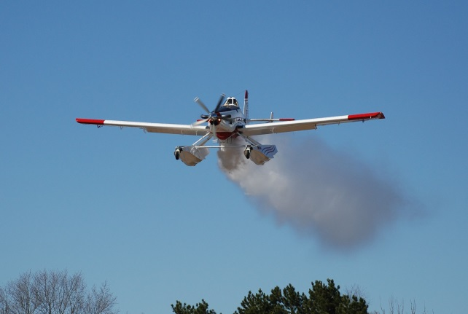
Buffers around the drop zone must be maintained to provide a safe working environment for ground personnel. These minimum standards should be followed:
Fixed Wing Operations: 200’ laterally for personnel & equipment 300’ in front of or behind canopied equipment 500’ in front of or behind unprotected personnel
Helicopter Operations: 50’ laterally for personnel & equipment 100’ in front of or behind personnel & equipment in grass/brush fuel types or canopied equipment in timber fuel types 1½ times the canopy height in front of or behind unprotected personnel in timber fuel types.
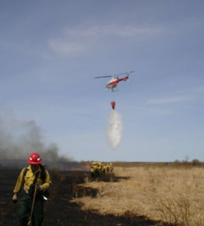
Equipment operators should have radio system that allows communication without interference from engine noise.
- ATGS communicates directly with equipment operator.
- ATGS communicates with TFLD who directs HEQB, DOZB or operator.
- Helicopter Manager (HMGB) can serve as TFLD, HEQB or DOZB.
Positive communication with all resources is critical for coordinating suppression tactics and is required for safe and effective operations. The ATGS, IC, DIVS, TFLD and HMGB should all communicate information and updates to give others the “big picture”.
Radio frequency management is critical for success when choreographing multiple assets on a large fire. Keeping resources on one frequency allows everyone to be aware of the big picture without relaying information. Additional frequencies must be employed when communication is hampered by frequency congestion.
- Area Frequency
- Tactical Frequencies
- Air to Ground Frequencies

