Retardants / Foam / Gels

Cooperating wildland fire management agencies use several types of wildland firefighting chemicals. The specific requirements, uses, and tactics for each type depend on the characteristics of the type of product. The following definitions may help to clarify the different types of products.

Personnel Safety All qualified wildland fire chemicals meet minimum requirements (June 2007) in regard to aquatic and mammalian toxicity (acute oral toxicity, acute dermal toxicity, primary skin irritation, and primary eye irritation). Specifications for long-term retardants, fire suppression foams, and water enhancers can be found on the US Forest Services Wildland Fire Chemicals (WFCS) website.

Human health risk from accidental drench with fire chemicals can be mitigated by washing with water to remove any residue from exposed skin.

Slippery footing is a hazard at storage areas, unloading and mixing sites, and wherever applied. All fire chemical concentrates and solutions contribute to slippery conditions. Firefighters should be aware that fire chemicals can conceal ground hazards.
Long-term retardants contain retardant salts (typically fertilizers) that alter the way the fire burns, decreasing the fire intensity and slowing the advance of the fire, even after the water they originally contained has evaporated.

Because long-term retardants continue to work after the water they contain has evaporated and continue to work for days or weeks until they are removed by rain or erosion, they are well suited for indirect and line building.

The water they contain when applied serves primarily to aid in uniform dispersal of the chemical over the target area. These products can be used for direct attack but they are only marginally more effective than water for this use.

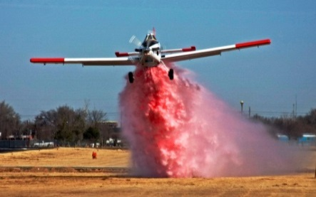
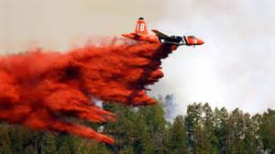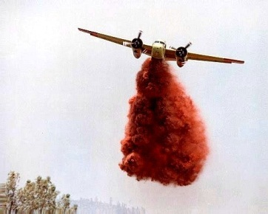

Foam fire suppressants contain foaming and wetting agents like those found in dishwashing detergents and other cleaners. The foaming agents affect the accuracy of an aerial drop, how fast the water drains from the foam and how well the product clings to the fuel surfaces. The wetting agents increase the ability of the drained water to penetrate fuels.

Foams depend on the water that they contain to suppress the fire. Once the water has evaporated there is no effectiveness. This property makes them most effective for direct attack and mop up.

Water enhancers (Gels) contain ingredients designed to alter the physical characteristics of water to increase effectiveness, accuracy of the drop, or adhesion to fuels. They also improve the ability of water to cling to vertical and smooth surfaces.

They depend on the water that they contain to suppress the fire. Once the water has evaporated they are no longer effective. This makes them well suited for direct attack or short-duration indirect attack.
They are also well suited to protection of structures and other vertical surfaces as the viscosity and stickiness of the products reduces runoff and retains more of the product on the fuels. This thicker layer of water may slow evaporation and absorb heat to a greater extent than a thin layer of plain water. The duration of effectiveness will depend on temperature, humidity, and exposure to UV/sunlight.
Increased use of gels in MN - (FireIce)

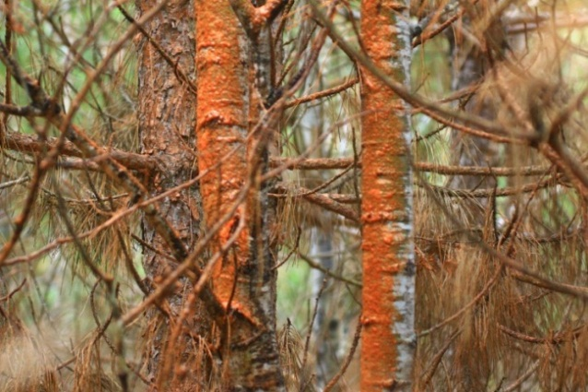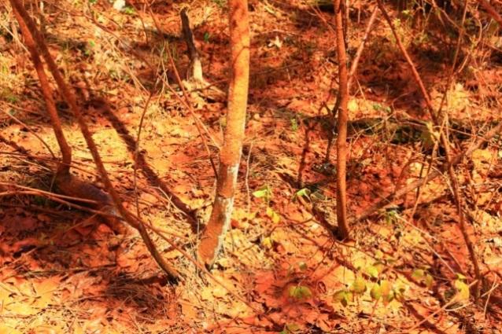
FireIce: canopy penetration and coating of fuels under the canopy.
FireIce is a water enhancer that not only coats fuels but has demonstrated an ability to absorb heat resulting in what appears to be improved extinguishing ability.
- FireIce is environmentally benign and odorless
- FireIce is a dry powder, which eliminates freezing / warm storage and periodic circulation issues commonly associated with other products
- Has a 15 year shelf life.
- FireIce is approximately one-third to one-half less expensive than our current retardant.
- Less weight per gallon/ increasing pilot safety margins
- Appears to have superior extinguishing ability
- Applications will vary based upon individual users and Area tactics
For MN DNR Forestry the continued use of FireIce is encouraged for initial loads in Single Engine Airtankers and FireBoss’.
Retardant is available at permanent tanker bases and may be available at temporary tanker bases. Retardant will remain the primary option for Large Airtankers and will also be used in SEATs when appropriate, especially in freezing temperatures.

