UNMANNED AIRCRAFT SYSTEMS (UAS) GUIDANCE
FOR UAS OPERATORS AND EMERGENCY RESPONDERS

UAS have several functions in Civilian Airspace throughout the Nation, including: law enforcement, homeland security, firefighting, weather prediction, tracking missions, agriculture information gathering, insect/disease detection, and observation.
There will be increased recreational, government, and commercial use of UAS in the future. Conflicts could occur if UAS are operating in the vicinity of a wildfire.
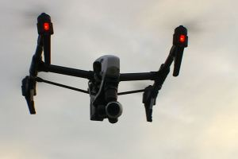
The FAA has partnered with several industry associations to promote Know Before You Fly, a campaign to educate the public about using unmanned aircraft safely and responsibly.
UAS operations are directed to remain clear of and not interfere with manned aircraft operations. UAS operators are not to conduct flights in a careless or reckless manner. UAS operators may be fined for endangering people or other aircraft.
In Minnesota during periods when weather and fuel conditions cause our forests and wetlands to burn, wildland fire agencies use helicopters and airplanes as part of their firefighting arsenal.

During these periods, up to 40 aircraft may be working or on stand-by in the State every day for aerial delivery of water, retardant, firefighters, cargo, and for fire detection. One or more aircraft may be dispatched to any fire in the State within minutes after it starts, depending on what is burning and the values that are threatened by the fire.
Pilots of fire suppression aircraft must work in an unfriendly environment, given the aerial hazards (powerlines, trees, towers), smoke, and windy conditions they encounter when they operate within 500’ of the ground. An additional hazard that could cause an accident is a UAS operating within 500’ of the ground.
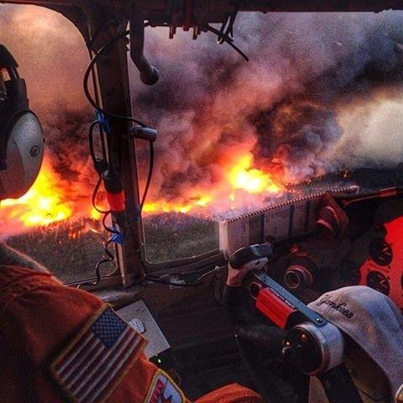
If UAS are encountered over a fire, aerial firefighters and pilots are directed to disengage from their missions until an airspace free of UAS is confirmed.

Voluntary cooperation by all UAS operators to not operate within 5 miles from fires will allow aerial firefighting resources to complete their task in a safe, efficient and effective manner.

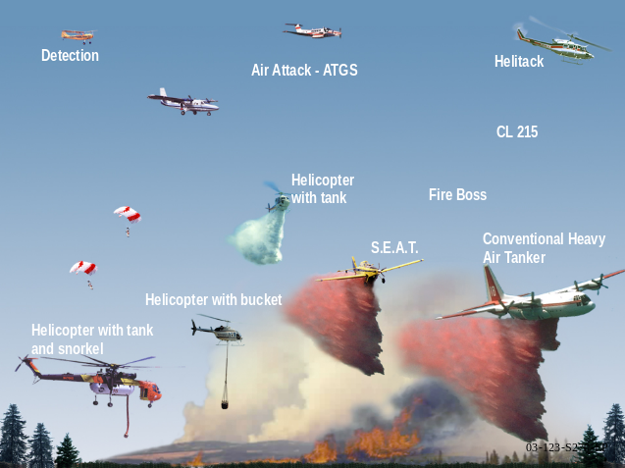Wildland fire agencies are hoping to create a culture of UAS operators that will recognize the hazard that is created when they operate over wildfires. The goal is to obtain an area free of non-emergency aircraft, including UAS, within a 5 mile radius of wildfires.

