EMERGENCY RESPONSE AIRCRAFT SOURCE LIST – MINNESOTA
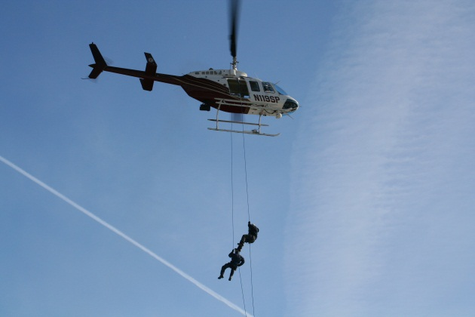
PURPOSE:
This document provides a source list of emergency response aviation assets in Minnesota. These emergency response aircraft are operated by various agencies and are based throughout the state.

Information includes emergency response aircraft capabilities, limitations, contact information, mobilization process and procedures. This information is provided to assist Incident Management Teams, Dispatchers, and State and Federal land management agencies to plan for and respond to requests for medical emergencies in remote locations.

Some of the aircraft are capable of conducting human extractions (hoist, short haul) for emergency evacuations. Both insertion/extraction techniques are used to precisely place emergency response personnel and also remove critically injured victims from normally inaccessible terrain.

MISSION GOALS:
- Provide on-scene emergency medical treatment.
  - Establish and manage landing areas for EMS Helicopters
  - Deliver medical equipment and/or personnel
- Provide emergency aerial transportation from remote site to:
  - Staging area to meet ambulance / medical personnel.
  - Staging area to transfer patient to EMS Helicopter.
  - Hospital via direct flight.
EMERGENCY RESPONSE AIRCRAFT SOURCE LIST – MINNESOTA

Aircraft | Ambulatory | Non-Ambulatory | Rappel | Short Haul | Hoist | Remote Landing Areas | Water Landings | Hover Exit | Cargo Drop
EMS Helicopters | X | X |  |  |  | X
State Patrol Helicopters | X |  | X | X |  | X
MN ARNG Helicopters | X | X |  |  | X | X
DNR Helicopters | X |  |  |  |  | X |  | X | X
DNR Enforcement | X |  |  |  |  | X | X
USFS Helicopters | X |  |  |  |  | X
USFS Beavers | X | X |  |  |  |  | X
ON MNR CL-415’s | X | X |  |  |  |  | X
ON MNR Helicopters | X |  |  |  |  | X |  | X

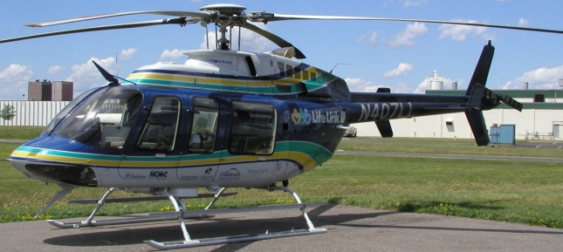
EMS HELICOPTERS

EMS HELICOPTER COMMUNICATION PLAN
VHF-AM | ARMER (800MHz) | VHF-FM
123.025 | Talkgroup As Assigned | “National EMS” (VMED28) 155.3400 (N) tone Tx 156.7
123.025 | Talkgroup As Assigned | “MINSEF” (VLAW31) 155.4750 (N) tone Tx 156.7
- Air-Air
  - Airspace coordination on VHF-AM
- Air-Ground
  - Helicopters are capable of both, ARMER (800MHz) and VHF-FM
  - Personnel involved in EMS helicopter operations – use the assigned 800MHz Talkgroup or VHF-FM (VMED28) as available and directed.
  - Statewide standard in MN is normally on ARMER
  - 911 Dispatcher can coordinate and confirm A-G frequency
To Request Assistance:
- *** Call 911 - First Responders / Ambulance Medical personnel should order through their county dispatcher.
Uses - EMS helicopter’s primary function is to land at the incident scene to pick up patient and transfer them to a hospital.
- EMS helicopters may be available for prepositioning at a large incident for quick response.
Landing Areas:
- Refer to the attached Helicopter Landing Zone (LZ) Requirement Guide
- Relay GPS Coordinates in Degrees and Decimal Minutes (DM)
- If LZ requirements cannot be created on scene, the patient may need to be relocated to a suitable site.
  - Relocation can be by ground using crews or vehicles
  - Relocation can be with a short haul/hoist operations aircraft
EMS HELICOPTERS THAT PROVIDE SERVICE IN MINNESOTA
Call - 1-800-328-1377 to request the closest EMS Helicopter
(This number is for the LifeLink III Dispatch, but they will find you the closest or next closest aircraft. If you are in NW MN, you can go direct to North, Sanford, or Valley Med)

Company | LifeLink III
Home Office | Minneapolis, MN
Phone Number | 612-638-4900
Dispatch Number | 800-328-1377
Helicopters | AW 119KX
Avionics | AM, FM, 800MHz
Locations | Hibbing, Willmar, Anoka/Blaine, Cloquet/Duluth, Alexandria; Rice Lake, WI

Company | Mayo Medical Transport
Home Office | Rochester
Phone Number | 507-255-5372
Dispatch Number | 800-237-6822
Helicopters | EC-145’s and BK-117’s
Avionics | AM, FM, 800MHz
Locations | Mankato, Rochester; Eau Claire, WI

Company | North Memorial
Home Office | Brooklyn Center
Phone Number | 763-520-5357
Dispatch Number | 800-247-0229
Helicopters | Augusta 109’s
Avionics | AM/FM/800
Locations | Brainerd, Bemidji, Princeton, Redwood Falls, Lakeville, Siren, WI
EMS HELICOPTERS THAT PROVIDE SERVICE IN MINNESOTA
(Con’t)
Call - 1-800-328-1377 to request the closest EMS Helicopter
(This number is for the LifeLink III Dispatch, but they will find you the closest or next closest aircraft. If you are in NW MN, you can go direct to North, Sanford, or Valley Med)

Company | Sanford Hospital
Home Office | Fargo, ND
Phone Number | 701-234-6054
Dispatch Number | 844-424-7633
Helicopters | EC-145
Avionics | AM/FM/800
Locations | Bemidji, MN; Fargo, ND; Sioux Falls, SD

Company | Valley Med Flight
Home Office | Grand Forks, ND
Phone Number | 701-739-3712
Dispatch Number | 800-828-0168
Helicopters | AS 350 B3
Avionics | AM/FM/800
Locations | Roseau, MN; Devils Lake, ND; Escanaba, MI
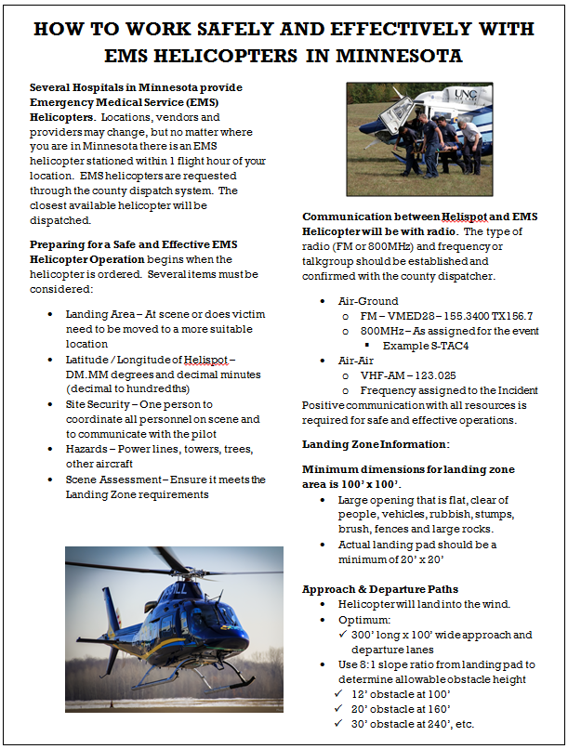
MN DEPT. OF PUBLIC SAFETY - STATE PATROL
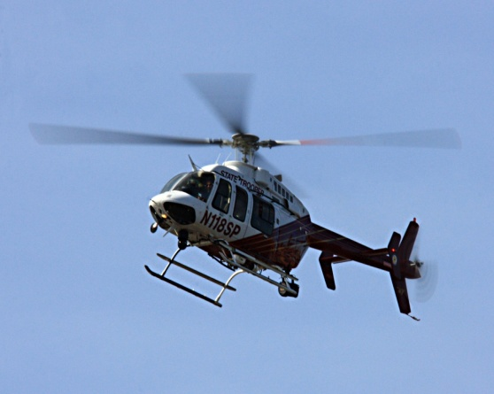
Helicopters -
- Trooper 8 – Bell 407
  - Location - St. Paul
  - Capabilities - Rappel / Short Haul
- Trooper 9 – Bell 206L 4
  - Location - St. Paul / Brainerd
  - Capabilities - Rappel / Short Haul
- Trooper 7 – Bell 206L 1
  - Location - St. Paul / Brainerd
  - Capabilities - Rappel
Avionics - AM/FM/800 MHz
Capabilities - The State Patrol utilizes members of the St. Paul Fire Dept. for rappel and short-haul. They have one paramedic on each crew. The other crewmembers are EMT’s. These firefighters are their Technical Rescue Team. They are trained to do high-risk procedures such as bluff rescues.
- Rappel - Remote site operation that delivers trained medical staff to the scene from a hovering helicopter.
- Short Haul – Remote site operation where patient litter is attached to a long-line that is attached to a helicopter and is lifted a short distance to a more suitable scene for treatment or transfer.
To Request Immediate Assistance – Contact State Patrol Dispatch Center- 651-582-1509
For Wildfire Response Planning – Contact the MIFC Aviation Desk - 218-327-4582.
Contact Information – MN State Patrol Aviation - St. Paul Holman Field, 651-296-3170. Dispatcher is Jaime (hi-mee) Santiago.
MINNESOTA ARMY NATIONAL GUARD (MN ARNG)
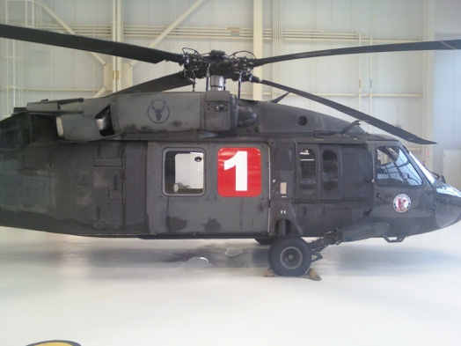
Helicopters – Blackhawks (UH-60)
Avionics - AM/FM/800MHz
Location – St. Cloud, MN – AASF #2

Capabilities - 2 units have Goodrich Hoists with a capacity of 600 lbs. and 250’-300’ of cable. Typical response time may be 4 or more hours. Flight Medics are part of the personnel complement in hoist operations. Upon ordering the MN ARNG you must specify that needs are for a hoist operation and which type of Flight Medic you require.
Requests should be made for a defined window of time. Long durations of stand-by are normally not acceptable.
Hoist Operations – Remote site operation where patient litter is attached to a cable that is lowered from a winch inside the helicopter. The helicopter hovers overhead while crewmembers are lowered to the scene, secure the patient in the litter, then the litter is lifted back to the helicopter for transport to a more suitable scene for treatment or transfer.
To Request Assistance - Contact the MIFC Aviation Desk at 218-327-4582. They should coordinate the dispatch of all MN ARNG assets. A Governor’s Executive Order is required to activate the MN ARNG.
Contact Information – MN ARNG - St. Paul Holman Field, 651-281-2404

MN DNR Forestry - Contract Helicopters

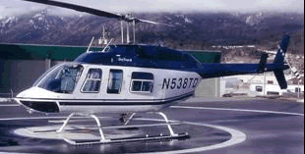
Helicopters -Type III- Light & Intermediate
Bell 206 B-III, Hughes 500 D,
206 L-1, 206 L-3, 206 L-4,
EC-130 B2
Avionics - AM/FM/800 MHz
Capabilities - Most are limited to delivering Helitack crews to helispots near the scene to improve helispots for EMS helicopter. They could also transport ambulatory victims to a staging area or hospital. Some pilots and crews are certified for hover- exit operations.
Hover-Exit - Helitack crew can depart the aircraft when the skids are 1’to 3’from the ground, or when the skids are touching a surface (example: a bog) that does not have adequate weight bearing capacity to allow normal landing. During this time the helicopter must remain under power (power-on landing).
Cargo Drop - Helicopters can hover close to the ground while trained Helitack personnel drop equipment such as chainsaws, medical supplies, trauma kits, etc. to ground personnel at the scene so they can improve the helispot or use medical equipment for patient treatment.
To Request Assistance - Contact the MIFC Aviation Desk at 218-327-4582. They should coordinate the dispatch for the closest, most qualified and available helicopter.

MN DNR - Division of Enforcement
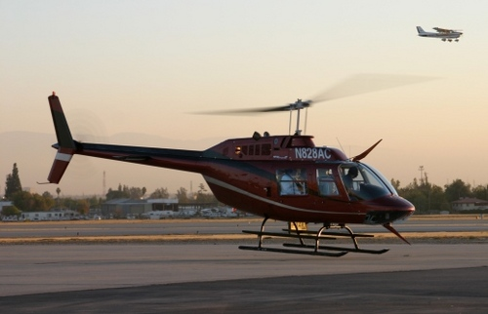
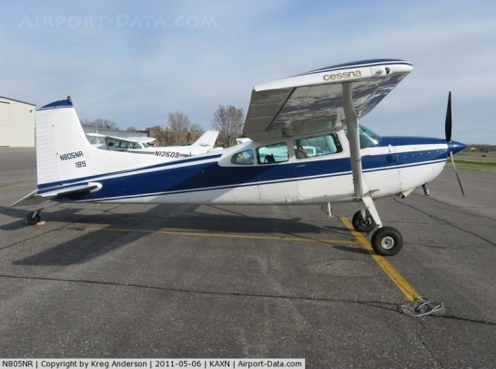
Fixed Wing Aircraft Helicopters
4- Cessna 185’s (2 amphibious) 2- OH-58
2- American Champion Scouts 1- Enstrom 480B (IR Camera)
1- MD 500E
Avionics - AM/FM/800 MHz
Capabilities - Primarily used for aerial Search and Rescue Operations – Helicopters could be used for delivering Helitack crews to helispots near the scene to improve helispots for EMS helicopter. Helicopters could also transport ambulatory victims to a staging area or hospital.
To Request Assistance - Contact the MIFC Aviation Desk at 218-327-4582. They should coordinate the dispatch for the closest, most qualified and available helicopter.

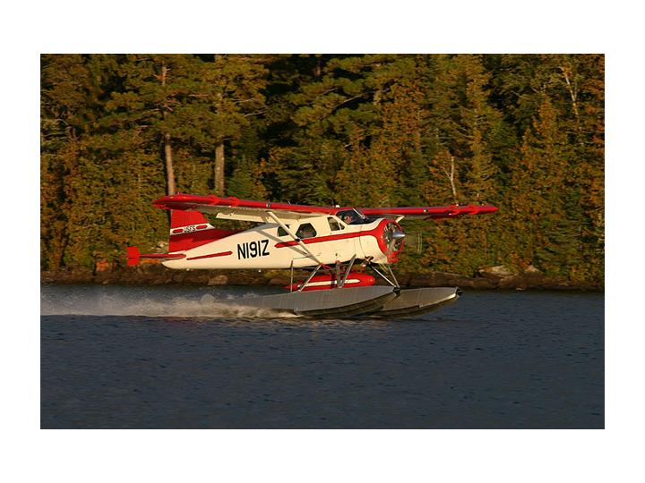
USFS - Superior National Forest
Fixed Wing Aircraft –
DHC-2 (DeHavilland Beaver)
Beaver 1
Beaver 2
Beaver 3

Location - Seaplane base on Shagawa Lake in Ely, MN
Avionics - AM/FM
Capabilities - Beavers are configures with floats in the summer and wheels/skis in the winter. Aircraft doors and seats can be removed to accommodate stretchers for a medevac flight. Beavers can carry 5 passengers and up to 2,000 lbs. They can also carry external loads, such as canoes. The plane could transport the patient or rescue victims to a nearby seaplane base or airport.
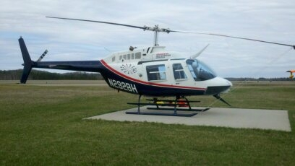
Helicopters -Type III- Light & Intermediate
Bell 206 B-III, 206 L-4 Avionics - AM/FM
Capabilities - Most are limited to delivering Helitack crews to helispots near the scene to improve helispots for EMS helicopter. They could also transport ambulatory victims to a staging area or hospital.
To Request Assistance - Contact Superior Dispatch at 218-327-4175. They should coordinate the request, briefings and dispatch of aircraft.
Ontario Ministry of Natural Resources - ONMNR
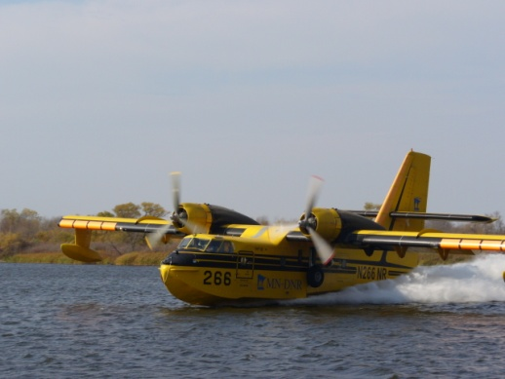
Fixed Wing Aircraft – CL-415’s

Location – Thunder Bay or Dryden, ON

Avionics - AM/FM

Capabilities - CL-415’s are amphibious aircraft that could land on water and make an emergency retrieval of personnel if no other means is available. This type of retrieval would only be used in life-threatening situations, and would require detailed briefings. A portion of the briefing should include a thorough risk assessment and analysis of the operation. The landing/take-off requirement for CL-415’s is approximately one mile of water surface. The plane could transport the patient or rescue victims to a nearby airport.
To Request Assistance - Contact the MIFC Aviation Desk at 218-327-4582. They should coordinate International Boundary Crossing Process and Procedures.

Ontario Ministry of Natural Resources & Forestry
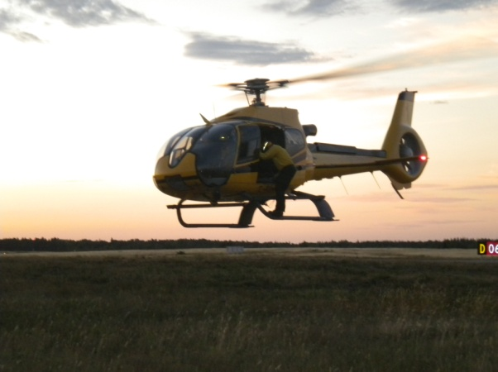
Helicopters - Euro copter EC-130 B4
Location – Thunder Bay or Fort Frances, ON
Avionics - AM/FM
Capabilities - Pilots and Helitack crews are certified for Hover-Exit operations.

Hover- Exit - Helitack crew can depart the aircraft when skids are 1’– 3’ from the ground, or when the skids are touching a surface, like a bog, that does not have adequate weight bearing capacity. The helicopter must remain under power (power-on landing).
Helitack crews can exit the aircraft near potential helispots with tools such as chainsaws to improve the helispot so an EMS helicopter can safely land on-site, or a suitable helicopter can land to either transfer the patient to a staging area to meet up with an EMS helicopter, or take the victim to a hospital.
To Request Assistance - Contact the MIFC Aviation Desk at 218-327-4582. They should coordinate International Boundary Crossing Process and Procedures.

