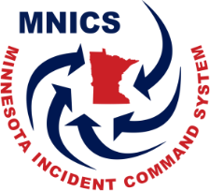

MNICS Working Team Charter (Template)

Title (can be a title page)

Date the charter is in effect (year format)

Mission Statement:

Goals

Organization:

Membership

Working Team Representation/Voting Members

Chair position rotation

Structure:

Responsibilities and Duties
  - Organization Chart
  - Working Team Members
  - Chairperson
  - Vice-Chairperson
  - Past Chairperson

Meetings

Annual Action Items

Ending Statement similar to:
“The Charter has been reviewed and agreed to by the MNICS Taskforce. The Charter will be reviewed every (3) years with the option to amend as needed.”

________________________________________________________________________________
A signature line for the Chair, Working Team and Date

________________________________________________________________________________
A signature line for the Chair, MNICS Taskforce and Date

