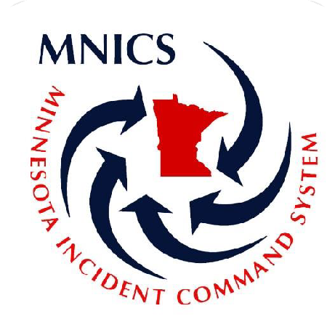

INTERAGENCY HANDCREW OPERATIONS GUIDE

*Approved and presented by the MNICS Operations Working Team*

***January 2025***







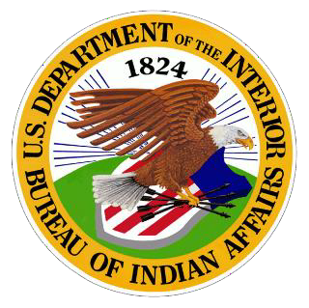





**Table of Contents**

MISSION 4

PROGRAM OVERSIGHT 4

CREW ROSTERING 4

Crew Structure-Interagency Type II IA Crew 4

BEING AVAILABLE 4

EQUIPMENT 5

Line Gear 5

Travel Bag 6

CREW EQUIPMENT 7

TRAVEL 7

CONDUCT AND DISCIPLINARY ACTIONS 7

Expectations 7

Uniform 8

Drugs, Alcohol, and Controlled Substances 8

Social Media and Cell Phone Use 9

Evaluations 9

Disciplinary Actions 9

CREW RULES 10

SAFETY 10

QUALIFICATIONS 11

ORGANIZATION 11

MINIMUM CREW STANDARDS FOR NATIONAL MOBILIZATION 12

CHAIN OF COMMAND / COMMUNICATIONS 13

DUTIES 13

Crew Boss 13

Crew Boss Trainee/Assistant 14

ICT5/ FFT1’s 14

Firefighters 14

Trainees 15

INJURIES AND ILLNESS 15

PHYSICAL FITNESS TRAINING 15

APPENDIX A – OPERATIONS WORKING TEAM CONTACT INFO 16

OPERATIONS WORKING TEAM CREW CONTACTS 16

APPENDIX B – SUGGESTED AND OPTIONAL FIRELINE PACK & TRAVEL BAG ITEMS 17

APPENDIX C – CREW BOSS/OVERHEAD CHECKLISTS 18

Prior to Assignment – Leaving MIFC with the Crew 18

Conduct a briefing prior to leaving MIFC 18

On Incident – In-brief with Operations Chief 19

After Assignment – Return to MNCC / Closeout 19

APPENDIX D – MNCC T2IA CREW STANDARD RESOURCE ORDER 20

# MISSION

The primary mission of the MNICS Interagency Type II IA crews is to provide a safety orientated, motivated, productive, and skilled team for all phases of wildland fire suppression and support during all risk/all hazard incidents. These crews will provide a quality learning experience for all personnel involved in leadership skills, technical skills and positive interpersonal communication. The crews will be composed of personnel from multiple agencies and organizations across Minnesota. The backbone of these crews will serve to improve interagency cooperation and communication, as well as establish positive professional relationships among fire managers and firefighters.

# PROGRAM OVERSIGHT

The MNICS Operations Working Team (OWT) provides overall guidance and clarification on all operations in respect to MNICS Crews. The OWTwill provide the initial input (in this document) into these operating guidelines, crew documentation, internet resources, and any other helpful guidance into creating smoother crew operations. The OWT will continue to support, evaluate, monitor, and adjust as needed, the Crew program as it relates to Interagency/Agency 20 person T2IA Crews, 10-person Suppression Modules, etc.

The MNICS Crew program currently does not have enough interest in rostered 20-person interagency crews. While still trying to support and guide Ad-Hoc 20 person Interagency/Agency crews as well as 10-person Suppression Modules (SMOD), we feel this document can still be used as a valid tool that provides guidelines for a variety of crews, knowing that each crew will be different depending on crew organization, number of people, and the CRWB.

# CREW ROSTERING

## Crew Structure-Interagency Type II IA Crew

Crew rostering and make-up will be a coordinated effort between MNCC Dispatch, the CRWB, and the agency Duty Officers. Regular employees should be given first chance over non-regular employees and ADs. Crew structure will meet minimum national standards.

# BEING AVAILABLE

When any individual is considering listing as available for a crew assignment, the below expectations must be met before mobilizing. If an individual cannot fulfill ALL of these expectations, they should not be made available. If an individual does not meet these expectations upon mobilizing, they will be at risk of being sent home.

1. Have a current and correct red card, along with supporting documentation for licenses, etc.
2. Have all the correct gear needed (or be able to obtain from the cache at mobilization). See Equipment section below.
3. Be ready to mobilize in an hour or two and meet the given mobilization time. Allowances will be made for those individuals coming from the far reaches of the state.
4. Answer the phone when called. Individuals will only be given a certain amount of time to accept the assignment and fill the request.
5. Be 100% healthy.
6. Wear the appropriate PPE when mobilizing. At the start of travel- nomex, boots and an agency shirt are acceptable.
7. All personnel must be self-sufficient. (Required PPE, 18 days of funding for hotels and meals)

# EQUIPMENT

Individuals are expected to, and are accountable for, maintaining all personal and line gear. Report of damaged items and requests for replacements should be made to their fireline supervisor before leaving the incident. Some lost or damaged items may be obtained through local incident supply cache.

Crewmembers will not check out supplies from fire camp unless directed to do so by the CRWB. In general, the crew will make a daily list of needed items and send one designee to the supply area to obtain and/or order needed items. This will prevent confusion when the crew demobilizes and must account for all non-consumable property assigned to the crew. All supplies and equipment checked out from the supply unit will be done through the CRWB or Squad Bosses only. All items checked out need to be returned prior to demobilization.

## Line Gear

It is vitally important to keep one’s line gear ready for fire at all times and should supply all needs for the course of long work shifts. On occasion, the crew will find itself in a temporary spike camp situation. In a spike camp, there will be little to no supplies available, other than what is packed in your line gear. Because you will work with your pack on, weight should be minimized, carry all the required equipment and minimize any unnecessary items. ***\*\*Note: line gear will be limited to 20 lbs. in travel status.*** The line gear items that are required are listed and described as follows:

**Pack:** Fireline packs should be durable and comfortable. The standard blue GSA fireline pack, or similar, will be the minimum standard for crewmembers, understanding that some people will prefer to use their own line gear for assignments.

**Hard-hat w/ chinstrap and shroud:** Each hard-hat and harness system should be periodically inspected and replaced if flaws appear or if they have been subjected to a sudden, heavy blow.

**Leather boots:** All boots need to be NFPA 1977 certified wildland firefighting boots; a minimum of 8 inches high, lace-type leather boots, or better, with non-slip, Vibram melt-resistant lug soles. It is strongly advised to have boots well broken in before wearing them on a fire assignment. Foot problems resulting from new boots are a common medical problem on hand crew assignments.

**Leather gloves:** Gloves are required at all times while on an incident.

**Fire shelter and rigid plastic sheath:** New Generation fire shelters are required for all aspects of wildland firefighting. Fire shelters should be inspected frequently and should be replaced if the pull strip becomes damaged, cracks appear (check folds closely), or if excessive abrasion occurs (look for gray dust). Fire shelters should be worn in an easily accessible place on the outside of your pack, avoid sitting or lying on it.

**One-quart canteens (four minimum):** It is advisable to carry 5 quarts of water with you daily, more may be required based on individual needs. To keep drinking water potable, change it every three to four days.

**Headlamp and batteries:** Check headlamp often to ensure it operates properly. Tip: While in your pack, keep a slip of paper between the battery contacts, this will ensure it does not get turned on accidentally. Always carry a spare set of fresh batteries.

**MRE or comparable ration:** Carry an MRE, or something similar, for long first shift situations or when other food means are not readily available on the fireline.

**Safety glasses or goggles:** Prescription glasses with safety lenses are also suitable. Safety glasses are required, especially when digging line, working with water, or operating a chain saw. Ensure that any sunglasses meet or exceed safety glass requirements.

**Fusees:** A minimum of 4 fusees should be carried by all personnel as firing devices, particularly if the need for firing off a safety zone or similar needs dictate. ***\*Remove fusees from pack when flying.***

**Additional Equipment:** Ear plugs, personal first aid kit, compass, IRPG, lighter, space blanket, rain gear (packable and lightweight), long sleeve shirt or sweatshirt, wool cap, high energy snacks, extra boot laces or parachute cord, spare socks, insect repellant, watch, pocketknife or multi-tool, GPS w/ case (if available), handheld radio (if available), toilet paper/wet wipes.

## Travel Bag

Each crew member must have a travel bag, or what is commonly called a “red bag”. The red bag should carry enough personal supplies to outfit a crewmember for a minimum of two weeks without doing laundry. Gear should be packed in plastic bags for additional protection from the elements. Name, crew number, agency, and address should be on every red bag. ***\*\*Note: personal travel bags are limited to 45 lbs. in travel status.*** With the exception of a sleeping pad and/or tent nothing may be strapped to the outside of bags.

### Required items:

* Up to date IQC (red card)
* TSA Approved Photo identification
* 2 pair of Nomex pants
* 2 Nomex shirts
* 1 sleeping bag
* 1 small tent
* 1 sleeping pad
* IRPG
* PT clothes/shoes

The following items must be furnished personally. This is not a hard and fast list. Be prepared to go a week or more before having to wash items. Get these items together BEFORE listing as “available”.

* 8+ pair of socks, heavy duty work style
* 8+ sets of underwear, all cotton *see below*
* 8 appropriate undershirts, all cotton *see below*
* 1 pair of long underwear
* 1 stocking cap/ball cap
* 1 pair of jeans/sweats (for camp/off the clock)
* 1 shirt and comfortable shorts (for camp/PT)
* 1 light jacket or sweatshirt (for camp)
* 1 pair of shoes and flip-flops (for camp / PT)
* 1 alarm clock (watch or cell phone work well)
* 1 towel/washcloth/ flip flops (for camp)
* 1 personal toiletries kit (toothbrush, toothpaste, deodorant, lip balm, clippers, mints, shaver)
* 3-week supply of prescription medications/personal needs (ibuprofen, tums, cough drops)
* PT (physical training) outfit (shorts, tennis shoes, tee shirt)
* Spending cash

**Optional:** boot grease, bandanas, pj’s, stuff sack for items, swimsuit, playing cards/book/etc., cell phone, spare prescribed glasses, go pro, warm coat, a pair of civilian clothes, charging cords/bank card.

## CREW EQUIPMENT

To be fully successful in providing a quality Type 2 IA crew, proper vehicles, tools and equipment will be necessary. Vehicles available for use of the crew will vary throughout the season depending upon unit availability from each agency. When driving, tools and other equipment needs will be available through the NEK Cache in Grand Rapids. Please see Appendix D for the standardized resource order designed for crews to check out from the cache. Depending on crew needs, this list may change slightly before departure from MNCC.

When flying to assignment, crews will only fly with travel bags and line gear. If there is a weight option to fly with limited tools, it is suggested to do so. Furthermore, when flying, Type 2 IA capability will be limited, and most likely not allow the crew to perform with IA capability unless there are rental vehicles available at the receiving end of the fire assignment.

All supplies and equipment checked out from the supply unit will be done through the CRWB or Squad Bosses only. All items checked out will be returned prior to demobilization. All supplies and equipment checked out from the NEK cache will be returned as soon as the crew returns home. If these items are not returned, it will come out of the respective agency’s budget.

# TRAVEL

When MNICS crews drive to their designated assignment, they typically travel with 6 vehicles, 5 crew carriers (crew cab pickups) and 1 overhead vehicle (ext. cab/crew cab pickup or SUV). Every attempt will be made to have at least one engine as a crew transport in order to make the crews more versatile for initial attack to the receiving unit. All agency vehicles that come with the crew should have a contact for the appropriate fleet manager for that respective agency vehicle(s) and be ready to travel (oil change and fluids up to date).

The MNICS agreement allows agencies to drive vehicles from all agencies. Tribal vehicles are not part of the agreement due to insurance reasons, so only folks from the respective tribe are allowed to operate such vehicles. For agencies that provide a vehicle, every attempt will be made to have at least 2 people from that agency on the crew to drive the given vehicle. Agency driving protocol within the red book will be followed as driving standards.

Crews will occasionally fly to their assignment, from a localized mobilization center, via a NICC jet or commercially. The NICC jet will carry 5 crews (100 people) at a time. With this mode of transportation, it is crucial that all crewmembers limit their collective gear weight to 65 pounds or less; 20 lbs. for line gear and 45 lbs. for travel bag, as the standard NICC jet crew weight is 5300 lbs. total. All unnecessary equipment and hazardous materials should be removed, including fusees, batteries, water, etc. At the receiving end of the incident, crews will typically get a bus or if lucky, 4-5 rental vehicles as transport. In the case of receiving a bus, the crew boss or assistant should make every attempt to get a chase vehicle from ground transportation. Furthermore, the attempt should be made to get 4-5 rental vehicles in order to make the crew more versatile during the assignment and as IA resources. Most always, crews with more versatile transportation will get better assignments.

# CONDUCT AND DISCIPLINARY ACTIONS

## Expectations

Members of the crew are expected to maintain a high standard of honesty, integrity and respect. Crewmembers will avoid any actions which: 1) may reflect negatively on the State of Minnesota, the MNICS organization, MNCC, the Type 2 IA crew program and the agency that they represent, or 2) would jeopardize the employee’s fitness for duty and ability to perform their job effectively. A crew member represents not only themselves and their agency, but all individuals and agencies represented on the crew.

It is imperative that supervisors support one another. There must be honest and direct communications within the leadership ranks to act as professionals and resolve disagreements or frustrations at any level of leadership. All discussions will be professional and respectful.

Disagreements will not be discussed on the radio under any circumstances. Negative comments about others will not be tolerated. Open complaining about an assignment given to the crew in front of others will not be tolerated.

Supervisors are expected to stop inappropriate behavior. Failure to do so implies approval through lack of action. Each supervisor is responsible to identify and resolve conflicts or disagreements between crewmembers. If you need help, follow the chain of command to get issues resolved.

**BE ON TIME**. When dispatched to an incident, report to the designated location NO LATER than the specified time, dressed in proper PPE and have appropriate IA gear and travel bag. **The crew assignment will be for 14 days plus travel, unless explicitly told otherwise by dispatch and the CRWB.** Individuals who cannot commit to a minimum of 18 days should not make themselves available. It is better to turn down the assignment than to jeopardize the entire crew being sent home early.

**BE PREPARED**. Keep personal items, such as boots, in serviceable condition. Government issued equipment such as pants, shirts, headlamps, batteries, and other equipment should be traded out as needed at the supply cache on the incident. **Do not wait until dispatch to do this.** All PPE, water, line gear, saw gas, and equipment needed for the next operational period should be procured prior to going off the current shift.

Individuals are responsible for maintaining a physical standard to safely perform the arduous work required in wildland firefighting (see page 19). The CRWB/ CRWB(t) is responsible for the well-being of crewmembers on the fire, but the crew is only as strong as its weakest link.

**BE RESPECTFUL**. Rude, inappropriate, or disrespectful behavior to any member of the general public, members of the incident organization, crew leadership or other crew members will be documented and may be grounds for being sent home, being benched from MNCC crews for the rest of the year or never being allowed on MNCC crews again. MNCC crewmembers come from many diverse backgrounds and cultures, it is crucial to keep this in mind and respect all other members of the crew. Crewmembers are expected to be kind, courteous, and professional at all times while on assignment. This is not to say the crew cannot have fun while on assignment.

**STAY HEALTHY**. Crew vehicles, fire camp and the fireline shall be kept clean and free of litter at all times. If you see someone else’s trash, please pick it up! Keep in mind that this is where you will be living and working for 14 days, so keep these places clean and organized at all times. While many individuals on crews chew tobacco, spitting on the ground in camp or in the chow line is unacceptable and will not be tolerated. Maintaining proper personal hygiene and camp cleanliness is crucial in minimizing exposure to camp crud.

## Uniform

Appearance is integral in gaining respect from receiving units/agencies/districts. It is suggested that individuals wear shirts such as fire department, crew, agency, or a plain, solid color, cotton t-shirt are also acceptable. Tank tops or sleeveless t-shirts are unacceptable forms of clothing, both for safety and appearance reasons. Once mobilized, the required uniform will also consist of fire resistant nomex pants and a belt. In addition, all crewmembers will wear quality constructed leather lace-up work boots; NFPA 1977 accepted, vibram lug sole, eight-inch tops or taller. Undergarments and socks should be made of non-synthetic materials. In fire camp, during travel, and when visible to the public, the members must wear a clean t-shirt or sweatshirt as stated above. (Tip: keep a clean crew shirt and pair of nomex pants reserved for travel home). Hats should consist of crew hats, agency uniform hats, or plain, solid color, baseball style caps. Any clothing items that are of offensive nature will be prohibited from being worn. Crew apparel is available at MIFC.

## Drugs, Alcohol, and Controlled Substances

The possession or use of controlled substances and alcohol is strictly prohibited while on assignment, in state or federal government property, in agency vehicles, or while in travel status. Any person who violates this policy, or who has knowledge of a violation and fails to report it to their supervisor, will immediately be removed from their duties on the crew and sent home. **There will be no warnings or second chances.**

## Social Media and Cell Phone Use

Good judgment is needed in the taking and sharing of photos, as well as information sharing and status updates through social media sites like Facebook, Twitter, text messages, and other methods/sites. As with any activity, we expect firefighters to adhere to the same professional standards of conduct on social media sites as they would in any other professional setting. Distributing pictures of inappropriate or unsafe actions and posting incorrect or classified information can be cause for termination. Remember that certain photos could be very sensitive to the individuals being adversely affected by a large fire or incident. Be respectful of their situation. As for anything that could be posted in social media, first ask yourself if you would be okay with your posting or picture on the front page of a major newspaper or on the nightly news channel.

Individuals will have plenty of opportunity during daily travel and down time after all crew needs are met for personal telephone use. Disciplinary action will result when personal telephone use interferes with job performance. Personal telephone usage abuse will result in a reprimand and imposed limitations for the entire crew during paid work hours. *Don’t abuse this privilege.

## Evaluations

Honest evaluations will be done on all individuals within the crew. The Crew Boss/CRWB (T) will conduct an evaluation for each ICT5/ FFT1, and each ICT5/ FFTI will do an evaluation on each respective crewmember within their squad. The CRWB/CRWBt will review performance for crewmembers before they are reviewed with the crewmembers. The CRWB and FFTIs may be evaluated as a whole by each crewmember upon return travel from the assignment, with review by the MNCC Coordinator. Conduct, whether good or bad, will be reflected on those evaluations, with poor evaluations resulting in suspension from subsequent crew rotations or ineligibility for the crews as a whole. Please see below for the tier disciplinary process. Copies of the evaluation will be given to the employee, the agency, and a copy will be stored in a MNICS approved file for the season, in the event that conduct issues should continue to arise.

## Disciplinary Actions

Disciplinary action will be initiated against anyone that exhibits behavior detrimental to the crew or unbecoming of any of the MNICS agencies. Most conduct and performance issues will be evaluated through a tier process. Insubordination, unlawful discrimination, and/or unlawful harassment of any kind (racial, sexual, etc.) and physical violence will not be tolerated and will result in immediate disciplinary actions and immediate removal from the crew regardless of motivation. Further follow up and disciplinary action will be left up to the respective agency.

### First Tier

The first tier can include verbal warnings. They will be conducted by the designated Squad Boss and/or Crew Boss and will be documented on a unit log for the duration of the assignment. Reprimands may be cause for suspension from the crews for the remainder of the current year. Continued or repeat occurrences of the same conduct or performance will be documented into the performance evaluation and failure to improve will dictate an unsuccessful rating. Unsuccessful ratings can lead to ineligibility of future crew assignments.

### Second Tier

The second tier will include a written warning, as well as a discussion with the Crew Boss and Squad Boss to develop a remedial plan for improvement. This warning will be filed using a unit log and attached to and included in the individual performance evaluation at the end of the assignment. Serious reprimands may be cause for suspension from the crews for the remainder of the current year and future years to follow.

Continued or repeat occurrences of the same conduct or performance will be further documented on unit logs, included in performance evaluations, and failure to improve will dictate an unsuccessful rating.

Unsuccessful ratings can lead to ineligibility for future crew rotations and discipline by your respective agency.

### Third Tier

The third tier is reserved for conduct or performance with such severity that does not allow for warning(s) to be issued either verbally or in writing, and will involve the Crew Boss, Squad Boss, and Agency representative, and in most cases a Human Resources Representative from your respective agency. A third-tier conduct violation could result in immediate dismissal from the crew.

*\* Any of the above tiers may dictate the need for a peer review process after the assignment.*

In many instances, issues and subsequent actions will be dealt with on a case-by-case basis, mainly between the Crew Boss, Squad Boss, the home unit, and the MNICS Task Force representative (or delegate). MNICS Task Force maintains the discretion to prevent individuals from crew assignments.

# CREW RULES

* Think first, then act responsibly.
* Respect others as well as yourself.
* Hold yourself and those around you accountable.
* Give your best effort and expect the same from others.
* Honesty and positive attitude are valued above all else.
* Take pride in your work and the work of the crew.

If these rules cannot be followed, demobilization may occur for an individual or even the entire crew. It is expected the crews will constantly strive to achieve an outstanding crew reputation. In order to accomplish that goal, the crewmembers must respect others, not only on the crew, but also any individual they interact with.

# SAFETY

Commitment to safety is a top priority of all MNCC operations. Wildland firefighting is an inherently dangerous business. All MNCC crews are committed to using safe and appropriate strategies and tactics. Crews are not to accept unsafe assignments. Safety is the primary responsibility of all members of the crew. MNCC crews will adhere to the ten standard fire orders at all times. The CRWB, CRWB(t) and FFT1’s will continually evaluate LCES and the 18 watch out situations during all phases of an assignment. If an assignment is deemed unsafe the crew boss will follow proper procedures as outlined in the Incident Response Pocket Guide, (page 19), to properly refuse risk.

* **Situational Awareness**: Observe surroundings, weather, topography, fire behavior and fuels. Maintain awareness to recognize changes in fire behavior and/or potential fire behavior.
* **Hazard Assessment**: Evaluate fire behavior and tactical hazards before making a move. Look for what can be harmful. Learn to recognize it.
* **Hazard Control**: Eliminate or reduce risk to an acceptable level before taking action. Mitigate all known hazards before starting work.
* **Decision Point**: If hazards can be mitigated, then proceed. Do not accept any assignment if hazards have not been mitigated. If you see something, say something! It may save your life.
* **Evaluate**: What has changed? Are the tactics working? Do new hazards exist? Any negative response to one of these questions may require a change in what you are doing.

**The following will help to minimize the risk of an accident to yourself or others:**

* Stay physically fit.
* Know your limitations.
* Think before you act.
* Listen attentively and contribute to safety briefings.
* Ask questions and clarify instructions.
* Wear your personal protective equipment.
* Drink plenty of water to stay properly hydrated.
* Report unsafe conditions immediately.
* Inform others of hazards.
* Learn from near misses.
* Tell your supervisor if you are not feeling well.
* Look out for your fellow crewmembers.
* Know and apply the 10 Standard Fire Fighting Orders and 18 Watch Out Situations.
* Maintain situational awareness.
* Know your escape route and safety zone locations at all times.
* Never assume the obvious.

# QUALIFICATIONS

All crew leadership will meet the minimum National Wildfire Coordinating Group (NWCG) standards for the position they are in, as well as those identified below. All crewmembers will be certified, at a minimum, as a Firefighter Type II (FFT2) under the NWCG standards. Crewmembers are encouraged to keep a personal record of their training. All taskbooks must be issued by their home unit prior to assignment. No task books will be issued during an assignment. It is the responsibility of each agency to ensure their personnel meets the minimum qualifications for each position in which they are certified. Each crewmember must provide a current red card as their incident qualification and certification to be checked by the crew boss prior to mobilization.

# ORGANIZATION

MNICS Type 2 IA handcrews strive to meet and exceed the minimum crew standards for national mobilization listed below. It is the duty and responsibility of the MNICS OWT and MNCC Dispatch is to ensure all crews meet the MNICS T2 IA crew minimum qualifications and standards.

## MINIMUM CREW STANDARDS FOR NATIONAL MOBILIZATION

## Graphic of crew standards requirements

Crews will generally consist of 20 people but may occasionally be dispatched with as few as 18 or as many as 21. The structure of the crew will include a CRWB, CRWB(t) or assistant CRWB, 3 ICT5/ FFT1s, 3 FAL2s, and 12 firefighters. Every attempt will be made to have an EMT or higher medically qualified individual on each crew.

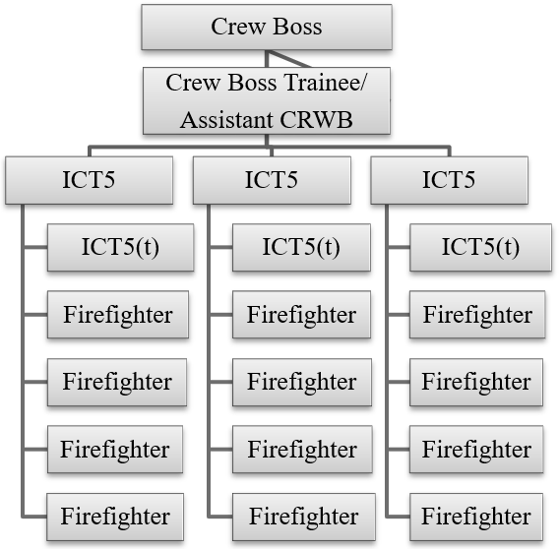

*FAL2 would replace ICT5(T) column*

# CHAIN OF COMMAND / COMMUNICATIONS

All crew member issues need to follow the chain of command, i.e. squad boss, crew boss. The crew boss will then take the appropriate action, contacting MNCC if needed.

# DUTIES

The duties of the crew are to suppress wildland fires, or respond to any other all-risk incident, while providing a “safety first” environment. The crew must be flexible in order to adapt to dynamic environments. That being said, Type 2 IA crews will have the capability to perform initial attack (IA) duties. The crew may be asked to break down from a standard crew configuration to squad IA configuration. However, even in IA modules, the span of control and chain of command will be followed. Each IA module will have one Faller 2 (FAL2) at a minimum.

## Crew Boss

The crew boss will have sufficient fire experience to provide capable leadership to the crew. The crew boss is responsible for the overall safety and management of the crew. The crew boss may serve as IC or fill other positions as needed on an incident only if capable leadership is identified prior to taking the position. Desired qualifications are Incident Commander Type 4 and Firing Boss (FIRB). Type 2 IA crews should be capable of performing burnout operations. Duties include:

* Responsible for providing a safe work environment.
* Identify strategy and tactics to accomplish mission objectives.
* Identify and mitigate risks associated with changing fire environment.
* Communicate hazards, risks and mitigation using the chain of command.
* Direct and lead crew operations.
* Provide for crew safety and welfare.
* Reward positive attitudes and behaviors; correct deficiencies.
* Provide a positive learning experience for all crewmembers, especially trainees.

## Crew Boss Trainee/Assistant

An Assistant Crew Boss may or may not be fully qualified as a CRWB. Regardless, the assistant must be qualified to supervise the crew in the absence of the crew boss. The assistant may serve as Incident Commander in initial attack configuration and must be qualified as at least a Single Resource Boss trainee and Incident Commander Type 5. Through a mutual/discretionary agreement between the CRWB and the CRWB(t), the CRWB(t) can assume the following duties:

* Assume full crew responsibility in absence of the Crew Boss if qualified.
* Provide supervision of Squad Leaders.
* Implement tactics designated by the Crew Boss. Provide suggestions and alternatives whenever necessary.
* Communicate hazards, risks and mitigation using the chain of command.
* Reward positive attitudes and behaviors; correct deficiencies.
* Ensure that parity exists between squads regarding duties, responsibilities and discipline.
* Ensure respectful interaction between all levels within the crew.

## ICT5/ FFT1’s

Three Squad Bosses provide day-to-day leadership for squad members. It is their responsibility to keep the crew boss and assistant informed on all aspects related to safe and effective crew operations. They will serve as IC on initial attack fires when the need arises. Duties include:

* Maintain situational awareness to help provide a safe work environment.
* Take immediate corrective action when necessary to ensure crew safety.
* Operate within the intent of given instructions and inform supervisors of minor tactical changes.
* Directly supervise and lead squad to implement assigned work.
* Communicate instructions and concerns within the chain of command.
* Orient, instruct and train crewmembers in basic fire behavior and safe operational tactics, to accurately assess the fire environment so they can safely implement assigned tactics.
* Ensure personal protective equipment is provided and used by all crewmembers.
* Ensure work areas, vehicles and equipment is clean and maintained.
* Report injuries and accidents. Recommend action to prevent recurrence.

## Firefighters

Firefighters are the members of the crew whose primary mission is to suppress wildfires or serve in other capacities during other emergency or natural resource assignments. The minimum qualification is firefighter type 2.

### Duties include:

* Responsible for personal safety.
* Look out for other crewmembers safety.
* Stay alert to hazardous conditions. Make them known to others.
* Use appropriate personal protective equipment.
* Maintain clean work areas, vehicles and equipment.
* Participate in briefings and tailgate safety sessions.
* Ask questions if assignment or information is unclear.
* Report all accidents and injuries to immediate supervisor.

Additional desired qualifications are to have at least one helicopter crewmember per squad, 3 FAL2s, and an EMT on the crew (in any position) for each assignment. In many cases, crews will be working with helicopters, possibly building sling loads, or landing in unimproved helispots, and working around hazardous trees that may need to be felled.

## Trainees

An important purpose of the MNICS Type 2 IA crews is to provide training and leadership opportunities. The crew will strive to have a minimum of one crew boss trainee and two ICT5/ FFT1 trainees on each assignment. Other trainee positions may also be accepted and are subject to the nature of the assignment. The priority will be to provide trainee opportunities as established for those qualified individuals from agencies or organizations represented on the crew.

# INJURIES AND ILLNESS

Crewmembers will report existing health conditions, allergies (medication, insects, etc.) to their supervisors and the crew EMTs at the beginning of any dispatch. Any obvious pre-existing conditions may preclude anyone from going on an assignment, at the CRWB discretion.

Injuries and illness contracted on the job must be reported to the immediate supervisor and documented **immediately, no** matter **how inconsequential they may seem**. Without proper attention, little problems can often develop into serious health threats. Compensation for medical treatment is unlikely for injuries that are not documented within 48 hours of the time they were incurred. Reporting of injuries and illness is the responsibility of the individual Firefighter.

# DISPATCH

MNCC will handle all mobilization of crews and will coordinate logistics with the crew boss.

GOING **THE EXTRA MILE.** MNCC crews will “go the extra mile” in all dealings with fellow firefighters as well as the public. Be sincere, courteous, and helpful in all dealings with the public. Go beyond the expected: fully answer questions, including unasked questions. Be informed: Know what is happening and know where to get timely and accurate information.

**Look sharp/be sharp.** Take pride in how you look. Wear the appropriate uniform appropriately. Make good first impressions. Remember last impressions are just as important as first impressions. Be courteous and respectful to everyone.

**Lead by example**. Demonstrate your professionalism every moment of every day. Remember a good leader must first be a good follower. We are not so much limited by our ignorance as we are by our assumptions. Ask questions, demand answers and THINK FIRST before acting.

# PHYSICAL FITNESS TRAINING

Fitness is absolutely vital to your job. Each crewmember is required to have a current red card, which includes passing the arduous work capacity test. Crewmembers that are in good shape are more productive, healthier, safer, and tend to receive more enjoyment from fire assignments. Considerable trust is extended to each and every crewmember in regard to physical fitness. Each firefighter must be in good shape BEFORE performing as a crewmember. It cannot be emphasized enough how important physical fitness is to perform the duties of a handcrew. You owe it to yourself and to your crew to be in the best shape possible, our lives may depend on it.

# APPENDIX A – MNICS CONTACTS

## OPERATIONS WORKING TEAM CONTACT INFO

* Phil Millette
* John Furr
* MNCC Dispatch/Representative

## OPERATIONS WORKING TEAM CREW CONTACTS

Greg Carlson

USNPS, Voyageurs NP

(218) 283-6666

[greg_carlson@nps.gov](mailto:greg_carlson@nps.gov)

B Gotchie BIA

(218) 335-7439

[robert.gotchie@llojibwe.net](mailto:robert.gotchie@llojibwe.net)

Phil Millette

USFWS, Morris

(612) 360-3999

[phil_millette@fws.gov](mailto:phil_millette@fws.gov)

Bill Alleman

Forester

MN DNR Forestry, Baudette

(218) 341-1068

[bill.alleman@state.mn.us](mailto:bill.alleman@state.mn.us)

AZFMO-TBD

Nick Petrack

218-666-0041

[nicolas.petrack@usda.gov](mailto:nicolas.petrack@usda.gov)

# APPENDIX B – SUGGESTED AND OPTIONAL FIRELINE PACK & TRAVEL BAG ITEMS

|  |  |  |
| --- | --- | --- |
| **Fireline Pack:**  Fire Shelter | MRE | Bandana |
| Spare Clamshell | Water bottles – Equaling 5 qt. | Flagging |
| Headlamp | Sunscreen | 1st Aid Kit |
| Compass | Toilet Paper | Orange Panel (HECM) |
| Baby Wipes | Glow Sticks | Size-Ups/Organizers (ICT5) |
| Tarp/Trash Bag IRPG | Anti-chafe cream | Stocking Cap |
| **PPE:**  2 pr. Gloves | 2-3 pr. Nomex Shirts | Hardhat |
| 2-3 pr. Nomex Pants Helmet Shroud | 1 pr. Boots Radio w/ bra | Hearing Protection |
| **Personal Gear Bag:**  Small Thermarest/ sleeping pad | Lightweight tent | Lightweight sleeping bag |
| Small pillow | Workout shoes | Sandals |
| Headlamp | Hand Lotion | Stocking cap |
| Razor/shaver | Shampoo | Vitamin C/Supplements |
| Deodorant | Aspirin | Gum (2) |
| Toothbrush | Toothpaste | 2 pr. Lights Socks |
| Anti-itch Cream | Gold Bond Powder | 8+ pr. Underwear |
| Plastic Bags | 8+ pr. Heavy Socks | 1 long-sleeve t-shirt |
| 1 sweatshirt | Lightweight jacket | 1 Packable towel |
| 5 fire t-shirts  (1 for return travel.) | 1 normal t-shirt | Tobacco products |
| 1 pr. Shorts | 1 pr. Swim trunks | Long johns (sleeping) |
| **On Person:**  Red Card | Leatherman/knife | Watch |
| Phone | Wallet | Purchasing card |
| Credit Cards | Cash | 2 pr. Sunglasses |
| Chap stick  Photo Identification | Baseball Cap | Gum/Tobacco |

# APPENDIX C – CREW BOSS/OVERHEAD CHECKLISTS

## Prior to Assignment – Leaving MIFC with the Crew

### Paperwork

* Make sure to get several copies of the resource order (for all overhead).
* All AD casual hire forms needed.
* Make any changes or additions needed to the equipment order. Additional equipment – Sigs, collapsible rakes, tarps, blue packs, shelters, etc.
* Contact lists (Personal and Emergency) – completed by all crewmembers.
* **Manifest** – Typed with phone numbers and qualifications for everyone, broken down by squad.
* Copies of everyone’s red card (5 copies). ***\*\*Helps to have folks bring these with them when they arrive.***
* Crew carrier inspections filled out prior to leaving MIFC (Note oil change needs) – Take photos of any prior damage for documentation upon return.
* AD Trip Itinerary (May be best to assign this to one of the ADs)
* **NICC jet** - Cargo weights not to exceed 65 lbs., 10 lbs. extra for CRWB and CRWB(t). Fly tools when available. Everyone needs to remove all unnecessary items from packs (batteries, fusees, MRE’s, etc.)

### Vehicles/Equipment

* All vehicles parked in the grass on the east side of parking area.
* Collect all personal vehicles keys, put them in an envelope, and leave it with the MIFC Coordinator.
* All home unit gear pulled from crew carriers (unless absolutely needed- at that point there is no responsibility for items being returned damaged). Set gear on a pallet to be segregated until return.
* Remove all saws from saw kits and make sure they run and function properly.
* Stress driving safety, parking/backing, stops/breaks along the way, etc.

### Personnel

* Yellow Packs – All gear will be transferred to a blue pack prior to leaving MIFC, no questions. Must be returned upon completion of assignment.
* All Old Generation fire shelters will be replaces with a New Generation fire shelter.
* 4-point hardhats will be swapped for the newer 6-point hardhats, no questions. Must be returned upon completion of assignment.
* Split personnel into appropriate squads, based on experience levels and qualifications (FALB, EMT, etc)

## Conduct a briefing prior to leaving MIFC

* Everyone is to be SELF-SUFFICIENT – cannot be stressed enough, no questions.
* ***MNCC crews are dry crews.*** Alcohol and drug use is not permitted upon departing MIFC.
* Laziness, poor work ethic, poor attitudes will not be permitted.
* Stress courtesy and consideration in public; eating, fueling, rest stops, overnight, etc.
* Parking / Backing of agency vehicles.
* All MURs/DUDs are filled daily and fuel receipts retained, regardless of the driver.

## On Incident – In-brief with Operations Chief

(**Crew Boss does this, not the trainee. Maintain a professional, neat appearance when this is done**.)

* + Hand the Ops. Chief a neat, squad-delineated manifest, along with an index card stating the following:
    1. The crew (MNCC1) may be broken into squads.
    2. Each squad has their own transportation.
    3. The crew (MNCC1) has 3 (or more) FAL2’s with saws.
    4. The crew (MNCC1) is self-sufficient.
    5. The crew (MNCC1) is experienced.

## After Assignment – Return to MNCC / Closeout

### Paperwork

* **Performance Evaluations** – Will be completed prior to return to MNCC. Evaluations shall be performed with each individual and signed off by both evaluator and individual. RULE - NO SURPRISES!! If the individual was not informed of any shortfalls prior to the evaluation, the individual should not be negatively graded, as they were given no chance to redeem their shortfall. It is up to the supervising official to keep things open and honest as they happen and to work things out as much as possible prior to a negative evaluation. Copies to the evaluator, employee, and MNCC.
* **MNCC Crew Debriefing Forms** – To be filled out by every individual prior to return arrival to MNCC.
* **Crew fire assignment evaluations** – Copies go to every individual and MNCC.
* **OF-288 (Red Dogs)** – Upon demobilization,
  + 1. DOA ADs - project return travel time, sign, and turn in OF-288s.
    2. DOI AD’s – retain original OF 288 and fill-in travel tune as return to their home unit.
    3. All agency regular employees retain their original OF-288s.
    4. Copies of all crewmember OF- 288s will go to MNCC.
* Copies of resource orders to everyone on the crew.
* Copies of experience records (with coding, fire sizes, etc.) to everyone on the crew.
* Email addresses on crew roster – goes to everyone on crew.

### Vehicles/Equipment

* All MNCC equipment returned to cache. Make sure necessary items are resupplied from the fire.
* Return personal keys to everyone with a car.
* All home unit equipment taken off of crew carriers should be replaced.
* Conduct final inspection on all vehicles to make sure there are no extra dents/dings. Finalize oil changes in Grand Rapids if necessary.
* *\*\*Ensure crew vehicles are* – cleaned, washed and return to the home unit in as good of shape (or better) as they came. Remember, the home unit went out of their way to send a vehicle to support the crew, so remember to return the favor.
* Gas cans need to come back empty.

### Personnel

* Strictly enforce the 2200 rule, no exceptions.
* Sit down with the MNCC representative, dispatch, and other representatives from MNCC. Be open and candid about the assignment and personnel; what went well, what didn’t go well, what needs to be improved for next time, who worked well, who shouldn’t go on assignment, etc. Remember, this is a learning experience for everyone, especially for future MNCC crews. Things can only be made better if the forum is open and honest, with rational discussion.

# APPENDIX D – MNCC T2IA CREW STANDARD RESOURCE ORDER

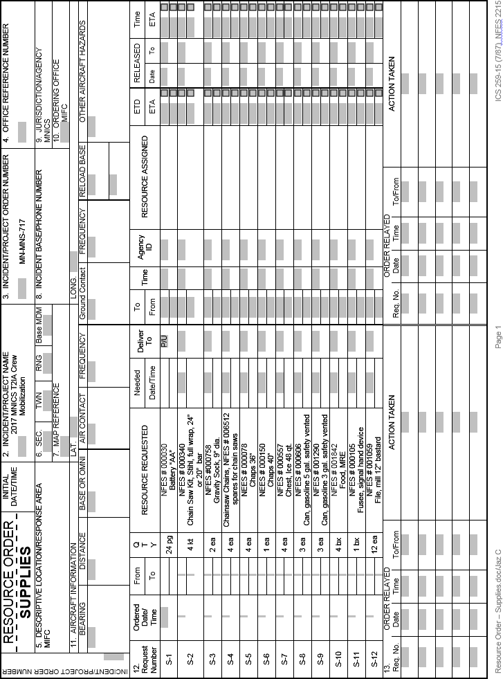***Note*-*** *S-9 is no longer available. The S-15 NFES number is 0909. Beginning in 2026 S-8 NESF number will be 0607.*

