
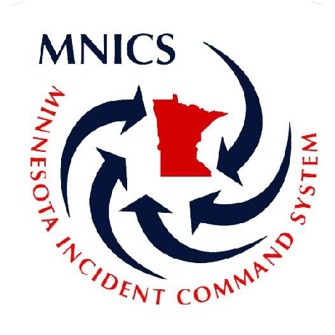


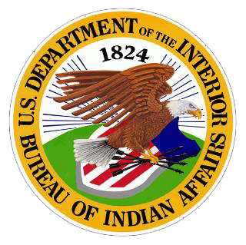



2025

MINNESOTA TYPE II IA INTERAGENCY HANDCREW OPERATIONS GUIDE

Approved and presented by the MNICS Operations Working Team January 2025
Table of Contents

Mission 3
Program Oversight 3
Formulating Crew Leadership 3
Application Process 3
MNICS Priority Trainee List (included in primary leadership section) 3
Primary Leadership Selection 3
Rotation 4
Crew Rostering 4
Crew Structure 4
Leadership Availability Expectations 4
Being Available 5
Equipment 5
Line Gear 5
Travel Bag 6
Crew Equipment 7
Travel 7
Conduct and Disciplinary Actions 8
Expectations 8
Uniform 9
Drugs and Controlled Substances 9
Alcohol 9
Social Media and Cell Phone Use 10
Evaluations 10
Disciplinary Actions 10
Crew Rules 11
Safety 11
Qualifications 12
Organization 12
Chain of Command / Communications 14
Duties 14
Crew Boss 15
Crew Boss Trainee/Assistant 15
ICT5/ FFT1s 15
Firefighters 16
Trainees 16
Injuries and Illness 16
Dispatch 16
Physical Fitness Training 17
APPENDIX A – Contacts 18
APPENDIX B – Travel Bag Items Checklist 19
APPENDIX C – Crew Boss /Overhead Checklist 20
APPENDIX D – Standard Resource Order 22

MISSION
The primary mission of the MNICS Interagency Type II IA crews is to provide a safety-oriented, motivated, productive, and skilled team for all phases of wildland fire suppression and support during all-risk/all-hazard incidents. These crews will provide a high-quality learning experience for all personnel involved in leadership, technical skill development, and positive interpersonal communication. The crews will be comprised of personnel from multiple agencies and organizations across Minnesota. The backbone of these crews will serve to improve interagency cooperation and communication, as well as establish positive professional relationships among fire managers and firefighters.

PROGRAM OVERSIGHT
The MNICS Operations Working Team (OWT) provides overall guidance and clarification on all MNICS operations. The OWT will provide initial input (in this document) on these operating guidelines, crew documentation, internet resources, and any other helpful guidance to create smoother crew operations. The OWT will continue to support, evaluate, monitor, and adjust as needed, the Crew program as it relates to Interagency/Agency 20-person T2IA Crews, 10-person Suppression Modules, etc.
The MNICS Crew program currently lacks sufficient interest in rostering 20-person interagency crews. While still trying to support and guide ad-hoc 20-person interagency or agency crews as well as 10-person suppression modules (SMOD), this document can still be used as a valid tool that provides guidelines for a variety of crews, knowing that each crew will be different depending on crew organization, number of people, and the crew boss (CRWB).

CREW ROSTERING

Crew Structure-Interagency Type II IA Crew
Crew rostering and make-up will be coordinated among MNCC Dispatch, the CRWB, and the agency Duty Officers. Regular employees should be given priority over non-regular employees and ADs. The crew structure will meet the minimum national standards.

BEING AVAILABLE
When an individual is considering listing themselves as available for a crew assignment, the following expectations must be met before mobilizing. If an individual cannot fulfill ALL of these expectations, they should not be made available. If an individual does not meet these expectations upon mobilizing, they will be at risk of being sent home.
- Have a correct and up to date red card, along with supporting documentation for licenses, etc.
- Have all the necessary and correct gear (or be able to obtain it from the cache at mobilization). See Equipment section below.
- Be ready to mobilize in an hour or two and meet the given mobilization time. Allowances will be made for those individuals coming from the far reaches of the state.
- Answer the phone when called. Individuals will only be given a certain amount of time to accept the assignment and fill the request.
- Be 100% healthy.
- Wear the appropriate PPE when mobilizing. At the start of travel, Nomex, boots, and an agency shirt are acceptable.
- All personnel must be self-sufficient. (Have all required PPE, funding for hotels/meals for 18 days)

EQUIPMENT
Individuals are expected to maintain all personal and line gear and are held accountable for doing so. Reporting damaged items and requesting replacements must be made to the fireline supervisor before leaving the incident. Some lost or damaged items may be obtained through the local incident supply cache.
Crew members will not check out supplies from fire camp unless directed to do so by the CRWB. In general, the crew will make a daily list of needed items and send one designee to the supply area to obtain and/or order needed items. This will prevent confusion when the crew demobilizes and must account for all non-consumable property assigned to the crew. All supplies and equipment checked out from the supply unit will be done through the CRWB or Squad Bosses only. All items checked out need to be returned prior to demobilization.

Line Gear
It is vitally important to keep line gear ready for fire response at all times and ensure the required equipment is packed. On occasion, the crew may be assigned to a temporary spike camp. Crew members should be aware that while in a spike camp, little to no supplies may be available beyond what is packed in the line gear. Because crew members wear packs while working, it’s critical to provide all necessary supplies for long work shifts and minimize unnecessary items.
**Note: line gear will be limited to 20 lbs. in travel status. The line gear items that are required are listed and described as follows:
Pack: Fireline packs should be durable and comfortable. The standard blue GSA fireline pack, or a similar pack, will be the minimum standard for crew members, recognizing that some people will prefer to use their own line gear for assignments.
Hard-hat w/ chinstrap and shroud: Each hard-hat and harness system should be periodically inspected and replaced if flaws appear or if they have been subjected to a sudden, heavy blow.
Leather boots: All boots must be NFPA 1977-certified wildland firefighting boots, at least 8 inches high from the bottom of the heel to the top of the boot, lace-up leather boots, with melt-resistant, non-slip lug soles (Vibram), heat-resistant stitching and good ankle support to meet safety standards. It is strongly advised to have boots that are well broken in before wearing them on a fire assignment. Foot problems resulting from new boots are a common medical issue on hand crew assignments.
Leather gloves: Gloves are required at all times while on an incident.
Fire shelter and rigid plastic sheath: New Generation fire shelters are required for all aspects of wildland firefighting. Inspect fire shelters frequently and replace when the pull strip is damaged, cracks appear (check folds closely), or when excessive abrasion occurs (look for gray dust). Fire shelters will be worn in an easily accessible place on the outside of the fire pack, in a placement that avoids sitting or lying on the shelter.
One-quart canteens (four minimum): Carrying five quarts of water daily is advised. However, more water may be required based on individual needs. Change packed drinking water every three to four days to keep it potable
Headlamp and batteries: Check headlamps frequently to ensure proper operation and always carry a spare set of fresh batteries. *Tip: Keep a slip of paper between the battery contacts of the headlamp when packed to prevent the light from accidentally switching on.
MRE or comparable ration: Carry an MRE, or something similar, for long first shift situations or when other food means are not readily available on the fireline.
Safety glasses or goggles: Prescription glasses with safety lenses are also suitable. Safety glasses are required, especially when digging a line, working with water, or operating a chainsaw. Ensure that any sunglasses meet or exceed safety glass requirements.
Fusees: A minimum of 4 fusees should be carried by all personnel as firing devices, particularly if the need for firing off a safety zone or similar needs dictate. *Remove fusees from pack if flying.
Additional Equipment: Ear plugs, personal first aid kit, compass, IRPG, lighter, space blanket, rain gear (packable and lightweight), long sleeve shirt or sweatshirt, wool cap, high energy snacks, extra boot laces or parachute cord, spare socks, insect repellant, watch, pocketknife or multi-tool, GPS w/ case (if available), handheld radio (if available), toilet paper/wet wipes.

Travel Bag
Each crew member must have a travel bag, commonly called a red bag. The red bag should carry enough personal supplies to outfit a crew member for at least two weeks without doing laundry. Gear should be packed in plastic bags for additional protection from the elements. Name, crew number, agency, and address should be on every red bag. **Note: personal travel bags are limited to 45 lbs. in travel status. With the exception of a sleeping pad and a tent, nothing may be strapped to the outside of bags.

Required Items:
- Up to date IQC (red card)
- TSA Approved Photo identification
- 2 pair of Nomex pants
- 2 Nomex shirts
- 1 sleeping bag
- 1 small tent
- 1 sleeping pad
- IRPG
- PT clothes/shoes
The following items must be furnished personally. This is not a hard and fast list. Be prepared to go a week or more before having to wash items. Get these items together BEFORE listing as “available”.
- 8+ pair of socks, heavy duty work style
- 8+ sets of underwear, all cotton *see below*
- 8 appropriate undershirts, all cotton *see below*
- 1 pair of long underwear
- 1 stocking cap/ball cap
- 1 pair of jeans/sweats (for camp/off the clock)
- 1 shirt and comfortable shorts (for camp/PT)
- 1 light jacket or sweatshirt (for camp)
- 1 pair of shoes and flip-flops (for camp / PT)
- 1 alarm clock (watch or cell phone work well)
- 1 towel/washcloth/ flip flops (for camp)
- 1 personal toiletries kit (toothbrush, toothpaste, deodorant, lip balm, clippers, mints, shaver)
- 3-week supply of prescription medications/personal needs (ibuprofen, tums, cough drops)
- PT (physical training) outfit (shorts, tennis shoes, tee shirt)
- Spending cash

Optional:
- boot grease, bandanas, pj’s, stuff sack for items, swimsuit, playing cards/book/etc., cell phone, spare prescribed glasses, go pro, warm coat, a pair of civilian clothes, charging cords/bank card.

CREW EQUIPMENT
To be fully successful in providing a quality Type 2 IA crew, proper vehicles, tools and equipment will be necessary. Vehicles available to the crew will vary throughout the season depending on unit availability from each agency. When driving, tools and other equipment needs will be available through the NEK Cache in Grand Rapids. Please see Appendix D for the standardized resource order designed for crews to check out from the cache. Depending on crew needs, this list may change slightly before departure from MNCC.
When flying to an assignment, crews will only fly with travel bags and line gear. If there is a weight option to fly with limited tools, it is recommended to choose it. Furthermore, when flying, Type 2 IA capability will be limited and most likely will not allow the crew to perform with IA unless rental vehicles are available at the receiving end of the fire assignment.
All supplies and equipment checked out from the supply unit will be done through the CRWB or Squad Bosses only. All items checked out will be returned prior to demobilization. All supplies and equipment checked out from the NEK cache will be returned as soon as the crew returns home. If these items are not returned, they will be charged to the respective agency’s budget.

TRAVEL
When MNICS crews drive to their designated assignment, they typically travel in six vehicles: five crew carriers (crew-cab pickups) and one overhead vehicle (ext. cab/crew-cab pickup or SUV). Every attempt will be made to have at least one engine serve as a crew transport to make the crews more versatile for the initial attack on the receiving unit. All agency vehicles that come with the crew should have a contact for the appropriate fleet manager for that respective agency vehicle(s) and be ready to travel (oil change and fluids up to date).
The MNICS agreement allows agencies to drive vehicles from all agencies. Tribal vehicles are not part of the agreement due to insurance reasons, so only folks from the respective tribe are allowed to operate such vehicles. For agencies that provide a vehicle, every attempt will be made to have at least 2 people from that agency on the crew to drive it. The Agency driving protocol within the Red Book will be followed as the driving standards.
Crews will occasionally fly to their assignment from a localized mobilization center, via a NICC jet or commercially. The NICC jet will carry 5 crews (100 people) at a time. With this mode of transportation, it is crucial that all crew members limit their collective gear weight to 65 pounds or less; 20 lbs. for their line gear and 45 lbs. for their travel bag, as the standard NICC jet crew weight is 5300 lbs. total. All unnecessary equipment and hazardous materials should be removed, including fusees, batteries, water, etc. At the receiving end of the incident, crews will typically get a bus or four to five rental vehicles as transport. In the case of receiving a bus, the crew boss or assistant should make every attempt to get a chase vehicle from ground transportation. Furthermore, every attempt will be made to get four to five rental vehicles to make the crew more versatile during the assignment and as IA resources. Most often, crews with more versatile transportation receive better assignments.

CONDUCT AND DISCIPLINARY ACTIONS

Expectations
Members of the crew are expected to maintain a high standard of honesty, integrity and respect. Crew members will avoid any actions that 1) may reflect negatively on the State of Minnesota, the MNICS organization, MNCC, the Type 2 IA crew program and the agency they represent, or 2) jeopardize the employee’s fitness for duty and ability to perform their job effectively. A crew member represents not only themselves and their agency, but all individuals and agencies represented on the crew.
It is imperative that supervisors support one another. There must be honest, direct communication within the leadership ranks to act professionally and resolve disagreements or frustrations at any level. All discussions will be professional and respectful.
Disagreements will not be discussed on the radio under any circumstances. Negative comments about others will not be tolerated. Open complaining about an assignment given to the crew in front of others will not be tolerated.
Supervisors are expected to stop any type of inappropriate behavior. Failure to do so implies approval by inaction. Each supervisor is responsible for identifying and resolving conflicts or disagreements between crew members. If you need help, follow the chain of command to resolve issues.
BE ON TIME. When dispatched to an incident, report to the designated location NO LATER than the specified time, dressed in proper PPE, and with appropriate IA gear and a travel bag. The crew assignment will be for 14 days plus travel, unless explicitly told otherwise by dispatch and the CRWB. Individuals who cannot commit to a minimum of 18 days should not make themselves available. It is better to turn down the assignment than to jeopardize the entire crew being sent home early.
BE PREPARED. Keep personal items, such as boots, in serviceable condition. Government-issued equipment, such as pants, shirts, headlamps, batteries, and other items, should be traded out as needed at the incident supply cache. Do not wait until dispatch to do this. All PPE, water, line gear, saw gas, and equipment needed for the next operational period should be procured before leaving the current shift.
Individuals are responsible for maintaining a physical standard to safely perform the arduous work required in wildland firefighting (see page 19). The CRWB/ CRWB(t) is responsible for the well-being of crew members on the fire, but the crew is only as strong as its weakest link.
BE RESPECTFUL. Rude, inappropriate, or disrespectful behavior toward any member of the general public, members of the incident organization, crew leadership, or fellow crew members will be documented and may be grounds for being sent home, being benched from MNCC crews for the rest of the year or never being allowed on MNCC crews again. MNCC crew members come from diverse backgrounds and cultures; it is crucial to keep this in mind and respect all other crew members. Crew members are expected to be kind, courteous, and professional at all times while on assignment. This is not to say the crew cannot have fun while on assignment.
STAY HEALTHY. Crew vehicles, fire camp and the fireline shall be kept clean and free of litter at all times. If you see someone else’s trash, please pick it up! Keep in mind that this is where you will be living and working for 14 days, so keep these places clean and organized at all times. While many individuals on crews chew tobacco, spitting on the ground in camp or in the chow line is unacceptable and will not be tolerated. Maintaining proper personal hygiene and camp cleanliness is crucial in minimizing exposure to camp crud.

Uniforms
Appearance is integral in gaining respect from receiving units, agencies and districts. Acceptable shirts include logo shirts from fire departments, crews, or home agencies, or plain, solid-color cotton t-shirts. Tank tops or sleeveless t-shirts are not acceptable forms of clothing, both for safety and appearance reasons. Once mobilized, in addition to the shirt requirements listed above, the required uniform will consist of fire-resistant Nomex pants and a belt. In addition, all crew members will wear quality constructed leather lace-up work boots that meet the NFPA 1977-certified wildland firefighting boot requirements - at least 8 inches high from the bottom of the heel to the top of the boot, lace-up leather boots, with melt-resistant, non-slip lug soles (Vibram), heat-resistant stitching and good ankle support to meet safety standards. While in fire camp, during travel, or when visible to the public, crew members must wear clean t-shirts or sweatshirts as stated above. (Tip: keep a clean crew shirt and pair of Nomex pants reserved for travel home). Hats must consist of crew hats, agency uniform hats, or plain, solid-color baseball-style caps. Any clothing items that are offensive in nature are prohibited from being worn. Crew apparel is available at MIFC.

Drugs, Alcohol, and Controlled Substances
The possession and/or use of controlled substances and alcohol is strictly prohibited while on assignment, on state or government property, in agency vehicles, or while in travel status. Any person who violates this policy, or who has knowledge of a violation and fails to report it to their supervisor, will immediately be removed from their duties on the crew and sent home. There will be no warnings or second chances.

Social Media and Cell Phone Use
Good judgment is a must when taking and sharing photos during a crew assignment, as well as when sharing status updates and information on social media sites like Facebook, X, Instagram, Snapchat, or in text messages, and other quick communication sources. As with any activity, we expect firefighters to adhere to the same professional standards of conduct on social media sites as they would in any other professional setting. Distributing pictures depicting inappropriate or unsafe actions, or posting incorrect or classified information, can result in termination. Remember, certain photos can be very sensitive to individuals who are adversely affected by a large fire or incident, whether the public, an agency, or the wildland firefighting community. Be respectful of everyone’s situation. Before posting to social media, ask yourself whether you would be okay with your post or picture making the front page of a major newspaper or appearing as a headline on any major news outlet.
Individuals will have plenty of opportunity during daily travel and downtime after all crew needs are met for personal telephone use. Disciplinary action will result when personal telephone use interferes with job performance. Personal telephone use abuse will result in a reprimand and the imposition of limitations on the entire crew during paid work hours. *Don’t abuse this privilege.

Evaluations
Honest evaluations will be conducted for all individuals on the crew. The Crew Boss/CRWB (T) will conduct an evaluation for each ICT5/ FFT1, and each ICT5/ FFTI will conduct an evaluation of each respective crew member within their squad. The CRWB/CRWBt will review performance for crew members before they are reviewed with the crew members. The CRWB and FFTIs may be evaluated as a whole by each crewmember upon return travel from the assignment, with review by the MNCC Coordinator. Conduct, whether good or bad, will be reflected on those evaluations, with poor evaluations resulting in suspension from subsequent crew rotations or ineligibility for the crews as a whole. Please see below for the tier disciplinary process. Copies of the evaluation will be given to the employee and the agency, and a copy will be stored in a MNICS-approved file for the season, in the event that conduct issues continue to arise.

Disciplinary Actions
Disciplinary action will be initiated against anyone who exhibits behavior detrimental to the crew or unbecoming of any MNICS agency. Most conduct and performance issues will be evaluated through a tiered process. Insubordination, unlawful discrimination, and/or unlawful harassment of any kind (racial, sexual, etc.) and physical violence will not be tolerated and will result in immediate disciplinary actions and immediate removal from the crew, regardless of motivation. Further follow-up and disciplinary action will be left up to the respective agency.
First Tier
The first tier can include verbal warnings. They will be conducted by the designated Squad Boss and/or Crew Boss and documented in a unit log for the duration of the assignment. Reprimands may result in suspension from the crews for the remainder of the current year. Continued or repeated occurrences of the same conduct or performance will be documented in the performance evaluation. Failure to improve will dictate an unsuccessful rating, and unsuccessful ratings can lead to ineligibility for future crew assignments.
Second Tier
The second tier will include a written warning and a discussion with the Crew Boss and Squad Boss to develop a remedial plan for improvement. This warning will be documented in a unit log and included in the individual performance evaluation at the end of the assignment. Serious reprimands may result in suspension from the crews for the remainder of the current year and future years.
Continued or repeated occurrences of the same conduct or performance will be further documented in unit logs and included in performance evaluations; failure to improve will result in an unsuccessful rating.
Unsuccessful ratings can lead to ineligibility for future crew rotations and discipline by your respective agency.
Third Tier
The third tier is reserved for conduct or performance with such severity that does not allow for warning(s) to be issued either verbally or in writing, and will involve the Crew Boss, Squad Boss, and Agency representative, and in most cases, a Human Resources Representative from your respective agency. A third-tier conduct violation could result in immediate dismissal from the crew.
* Any of the above tiers may dictate the need for a peer review process after the assignment.
In many instances, issues and subsequent actions will be handled on a case-by-case basis, primarily between the Crew Boss, the Squad Boss, the home unit, and the MNICS Task Force representative (or delegate). MNICS Task Force maintains the discretion to prevent individuals from crew assignments.

CREW RULES
- Think first, then act responsibly.
- Respect others as well as yourself.
- Hold yourself and those around you accountable.
- Give your best effort and expect the same from others.
- Honesty and positive attitude are valued above all else.
- Take pride in your work and the crew’s work.
If these rules are not followed, demobilization may occur for an individual or the entire crew. It is expected that the crews will constantly strive to achieve an outstanding crew reputation. To accomplish that goal, crew members must respect others, not only their fellow crew members but also any individuals they interact with.

SAFETY
Safety is a top priority for all MNCC operations. Wildland firefighting is inherently dangerous. All MNCC crews are committed to using safe and appropriate strategies and tactics. Crews are not to accept unsafe assignments. Safety is the primary responsibility of all crew members. MNCC crews will adhere to the ten standard fire orders at all times. The CRWB, CRWB(t), and FFT1s will continually evaluate LCES and the 18 watch-out situations during all phases of an assignment. If an assignment is deemed unsafe, the crew boss will follow the procedures outlined in the Incident Response Pocket Guide (page 19) to properly refuse the risk.
- Situational Awareness: Observe surroundings, weather, topography, fire behavior and fuels. Maintain awareness to recognize changes in fire behavior or potential fire behavior.
- Hazard Assessment: Evaluate fire behavior and tactical hazards before moving. Look for what can be harmful. Learn to recognize it.
- Hazard Control: Eliminate or reduce risk to an acceptable level before taking action. Mitigate all known hazards before starting work.
- Decision Point: If hazards can be mitigated, then proceed. Do not accept any assignment if hazards have not been mitigated. If you see something, say something! It may save your life.
- Evaluate: What has changed? Are the tactics working? Do new hazards exist? Any negative response to one of these questions may require a change in what you are doing.
The following will help to minimize the risk of an accident to yourself or others:
- Stay physically fit.
- Know your limitations.
- Think before you act.
- Listen attentively and contribute to safety briefings.
- Ask questions and clarify instructions.
- Wear your personal protective equipment.
- Drink plenty of water to stay properly hydrated.
- Report unsafe conditions immediately.
- Inform others of hazards.
- Learn from near misses.
- Tell your supervisor if you are not feeling well.
- Look out for your fellow crew members.
- Know and apply the 10 Standard Fire Fighting Orders and 18 Watch Out Situations.
- Maintain situational awareness.
- Know your escape route and safety zone locations at all times.
- Never assume the obvious.

QUALIFICATIONS
All crew leadership will meet the minimum National Wildfire Coordinating Group (NWCG) standards for the position they are in, as well as those identified below. All crew members will be certified, at a minimum, as a Firefighter Type II (FFT2) under the NWCG standards. Crew members are encouraged to keep a personal record of their training. All task books must be issued by their home unit prior to assignment. No task books will be issued during an assignment. It is the responsibility of each agency to ensure its agency personnel meet the minimum qualifications for each position in which they are certified. Each crew member must provide a current red card as their incident qualification and certification to be checked by the crew boss prior to mobilization.

ORGANIZATION
It is the duty and responsibility of the MNICS OWT and MNCC Dispatch to ensure all crews meet the minimum qualifications and standards of the MNICS T2 IA crews. MNICS Type 2 IA hand crews strive to meet and exceed the minimum crew standards for national mobilization listed on the next page.

MINIMUM CREW STANDARDS FOR NATIONAL MOBILIZATION
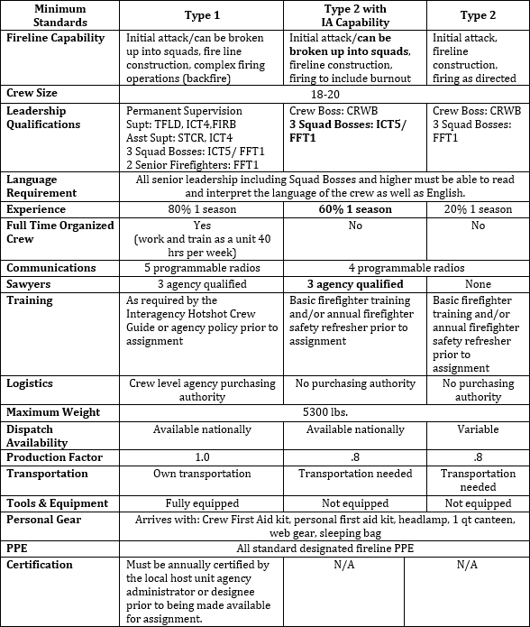

Crews will generally consist of 20 people, although they may occasionally be dispatched with as few as 18 or as many as 21. The crew will be comprised of a CRWB, a CRWB(t) or an assistant CRWB, 3 ICT5/FFT1s, 3 FAL2s, and 12 firefighters. Every attempt will be made to have an EMT or higher-qualified medical professional on each crew.
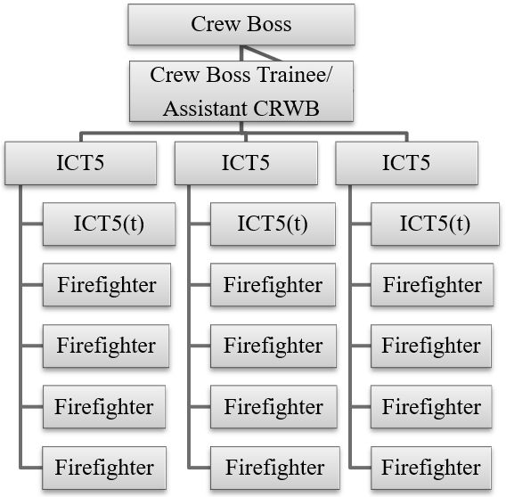

FAL2 would replace ICT5(T) column

CHAIN OF COMMAND / COMMUNICATIONS
All crew member issues must follow the chain of command, i.e., squad boss, crew boss. The crew boss will then take the appropriate action, contacting MNCC if needed.

DUTIES
The crew's duties are to suppress wildland fires or respond to any other all-risk incident while providing a “safety first” environment. The crew must be flexible in order to adapt to dynamic environments. That said, Type 2 IA crews will be able to perform initial attack (IA) duties. The crew may be asked to break down from a standard crew configuration to a squad IA configuration.
However, even in IA modules, the span of control and chain of command will be followed. Each IA module will have at least one Faller 2 (FAL2).

Crew Boss
The crew boss will have sufficient fire experience to provide capable leadership to the crew. The crew boss is responsible for the crew's overall safety and management. The crew boss may serve as IC or fill other positions as needed on an incident, provided capable leadership is identified prior to taking the position. Desired qualifications are Incident Commander Type 4 and Firing Boss (FIRB). Type 2 IA crews should be capable of performing burnout operations. Duties include:
- Responsible for providing a safe work environment.
- Identify strategy and tactics to accomplish mission objectives.
- Identify and mitigate risks associated with changing fire environment.
- Communicate hazards, risks and mitigation using the chain of command.
- Direct and lead crew operations.
- Provide for crew safety and welfare.
- Reward positive attitudes and behaviors; correct deficiencies.
- Provide a positive learning experience for all crew members, especially trainees.

Crew Boss Trainee/Assistant
An Assistant Crew Boss may or may not be fully qualified as a CRWB. Regardless, the assistant must be qualified to supervise the crew in the absence of the crew boss. The assistant may serve as Incident Commander in the initial attack configuration and must be qualified as a Single Resource Boss trainee and as an Incident Commander Type 5. Through a mutual/discretionary agreement between the CRWB and the CRWB(t), the CRWB(t) can assume the following duties:
- Assume full crew responsibility in absence of the Crew Boss if qualified.
- Provide supervision of Squad Leaders.
- Implement tactics designated by the Crew Boss. Provide suggestions and alternatives whenever necessary.
- Communicate hazards, risks and mitigation using the chain of command.
- Reward positive attitudes and behaviors; correct deficiencies.
- Ensure that parity exists between squads regarding duties, responsibilities and discipline.
- Ensure respectful interaction between all levels within the crew.

ICT5/ FFT1’s
Three Squad Bosses provide day-to-day leadership for squad members. It is their responsibility to keep the crew boss and assistant informed on all aspects related to safe and effective crew operations. They will serve as the IC for initial attack fires when needed. Duties include:
- Maintain situational awareness to help provide a safe work environment.
- Take immediate corrective action when necessary to ensure crew safety.
- Operate in accordance with the given instructions and inform supervisors of minor tactical changes.
- Directly supervise and lead the squad to implement assigned work.
- Communicate instructions and concerns within the chain of command.
- Orient, instruct, and train crew members in basic fire behavior and safe operational tactics to accurately assess the fire environment and safely implement assigned tactics.
- Ensure personal protective equipment is provided and used by all crew members.
- Ensure work areas, vehicles and equipment are clean and maintained.
- Report injuries and accidents. Recommend action to prevent recurrence.

Firefighters
Firefighters are the members of the crew whose primary mission is to suppress wildfires or serve in other capacities during other emergency or natural resource assignments. The minimum qualification is firefighter type 2.
Duties include:
- Responsible for personal safety.
- Look out for the other crew members' safety.
- Stay alert to hazardous conditions. Make them known to others.
- Use appropriate personal protective equipment.
- Maintain clean work areas, vehicles and equipment.
- Participate in briefings and tailgate safety sessions.
- Ask questions if the assignment or information is unclear.
- Report all accidents and injuries to the immediate supervisor.
Additional desired qualifications include having at least one helicopter crew member per squad, 3 FAL2s, and an EMT on the crew (in any position) for each assignment. In many cases, crews will be working with helicopters, possibly building sling loads, or landing in unimproved helispots, and working around hazardous trees that may need to be felled.

Trainees
An important purpose of the MNICS Type 2 IA crews is to provide training and leadership opportunities. The crew will strive to have a minimum of one crew boss trainee and two ICT5/ FFT1 trainees on each assignment. Other trainee positions may also be accepted, subject to the nature of the assignment. The priority will be to provide trainee opportunities as established for those qualified individuals from agencies or organizations represented on the crew.

INJURIES AND ILLNESS
Crew members will report any existing health conditions and allergies (medication, insects, etc.) to their supervisors and the crew EMTs at the beginning of each dispatch. Any obvious pre-existing conditions may preclude anyone from going on an assignment at the CRWB's discretion.
Injuries and illnesses incurred on the job must be reported to the immediate supervisor and documented immediately, regardless of how inconsequential they may seem. Without proper attention, little problems can often develop into serious health threats. Compensation for medical treatment is unlikely for injuries that are not documented within 48 hours of their occurrence. Reporting of injuries and illness is the responsibility of the individual Firefighter.

DISPATCH
MNCC will handle all crew mobilization and coordinate logistics with the crew boss.
GOING THE EXTRA MILE. MNCC crews will “go the extra mile” in all dealings with fellow firefighters as well as the public. Be sincere, courteous, and helpful in all dealings with the public. Go beyond the expected: fully answer questions, including unasked questions. Be informed. Know what is happening and where to get timely, accurate information.
Look sharp/be sharp. Take pride in how you look. Wear the appropriate uniform appropriately. Make good first impressions. Remember, last impressions are just as important as first impressions. Be courteous and respectful to everyone.
Lead by example. Demonstrate your professionalism every moment of every day. Remember, a good leader must first be a good follower. We are not so much limited by our ignorance as we are by our assumptions. Ask questions, demand answers and THINK FIRST before acting.

PHYSICAL FITNESS TRAINING
Fitness is absolutely vital to your job. Each crew member is required to have a current red card, including passing the arduous work capacity test. Crew members who are in good shape are more productive, healthier, and safer, and tend to receive more enjoyment from fire assignments. Considerable trust is placed in each crew member regarding physical fitness. Each firefighter must be in good shape BEFORE performing as a crewmember. It cannot be emphasized enough how important physical fitness is to perform the duties of a hand crew. You owe it to yourself and to your crew to be in the best shape possible; your crew members’ lives may depend on it.

APPENDIX A – OPERATIONS WORKING TEAM CONTACT INFO
- Phil Millette
- John Furr
- MNCC Dispatch/Representative

OPERATIONS WORKING TEAM CREW CONTACTS
Greg Carlson
USNPS, Voyageurs NP
(218) 283-6666
greg_carlson@nps.gov

BJ Gotchie BIA
(218) 335-7439
robert.gotchie@llojibwe.net

Phil Millette
USFWS, Morris
(612) 360-3999
phil_millette@fws.gov

Bill Alleman
Forester
MN DNR Forestry, Baudette
(218) 341-1068
bill.alleman@state.mn.us

AZFMO-TBD
Nick Petrack
218-666-0041
nicolas.petrack@usda.gov

APPENDIX B – SUGGESTED AND OPTIONAL FIRELINE PACK & TRAVEL BAG ITEMS

Fireline Pack:  Fire Shelter | MRE | Bandana
Spare Clamshell | Water bottles – Equaling 5 qt. | Flagging
Headlamp | Sunscreen | 1st Aid Kit
Compass | Toilet Paper | Orange Panel (HECM)
Baby Wipes | Glow Sticks | Size-Ups/Organizers (ICT5)
Tarp/Trash Bag IRPG | Anti-chafe cream | Stocking Cap
PPE:  2 pr. Gloves | 2-3 pr. Nomex Shirts | Hardhat
2-3 pr. Nomex Pants Helmet Shroud | 1 pr. Boots Radio w/ bra | Hearing Protection
Personal Gear Bag:  Small Thermarest/ sleeping pad | Lightweight tent | Lightweight sleeping bag
Small pillow | workout shoes | Sandals
Headlamp | Hand Lotion | Stocking cap
Razor/shaver | Shampoo | Vitamin C/Supplements
Deodorant | Aspirin | Gum (2)
Toothbrush | Toothpaste | 2 pr. Lights Socks
Anti-itch Cream | Gold Bond Powder | 8+ pr. Underwear
Plastic Bags | 8+ pr. Heavy Socks | 1 long-sleeve t-shirt
1 sweatshirt | Lightweight jacket | 1 Packable towel
5 fire t-shirts (1 for return tvl.) | 1 normal t-shirt | Tobacco products
1 pr. Shorts | 1 pr. Swim trunks | Long johns (sleeping)
On Person:  Red Card | Leatherman/knife | Watch
Phone | Wallet | Purchasing card
Credit Cards | Cash | 2 pr. Sunglasses
Chap stick  Photo Identification | Baseball Cap | Gum/Tobacco

APPENDIX C – CREW BOSS/OVERHEAD CHECKLISTS

Prior to Assignment – Leaving MIFC with the Crew
Paperwork
- Make sure to get several copies of the resource order (for all overhead).
- All AD casual hire forms needed.
- Make any changes or additions needed to the equipment order. Additional equipment – Sigs, collapsible rakes, tarps, blue packs, shelters, etc. ……………………………………….
- Contact lists (Personal and Emergency) – completed by all crew members.
- Manifest – Typed, broken down by squads, with phone numbers and qualifications for everyone.
- Copies of everyone’s red card (5 copies). **Helps to have folks bring these with them when they arrive.
- Crew carrier inspections filled out prior to leaving MIFC (Note oil change needs) – Take photos of any prior damage if needed for documentation after return.
- AD Trip Itinerary (May be best to assign this to one of the ADs)
- NICC jet - Cargo weights not to exceed 65 lbs., 10 lbs. extra for CRWB and CRWB(t). Fly tools when available. Everyone needs to remove all unnecessary items from packs (batteries, fusees, MRE’s, etc.)
Vehicles/Equipment
- All vehicles parked in the grass on the east side of parking area.
- Get keys of all personal vehicles and put in a manila envelope to give to the MIFC Coordinator.
- All home unit gear pulled from crew carriers (unless absolutely needed- at that point there is no responsibility for items being returned damaged). Set gear on a pallet to be segregated until return.
- Remove all saws from saw kits and make sure they run and function properly.
- Stress driving safety, parking/backing, stops/breaks along the way, etc.
Personnel
- Yellow Packs – All gear will be transferred to a blue pack prior to leaving MIFC, no questions. Must be returned upon completion of assignment.
- Old Generation fire shelters will be swapped for a New Generation fire shelter, no questions.
- 4-point hardhats will be swapped for the newer 6-point hardhats, no questions. Must be returned upon completion of assignment.
- Split personnel into appropriate squads, based on experience levels and qualifications (FALB, EMT, etc)
Conduct a briefing prior to leaving MIFC
- Everyone is to be SELF-SUFFICIENT – cannot be stressed enough, no questions.
- Alcohol/drug use upon leaving MIFC is not permitted, no questions. MNCC crews are dry crews.
- Laziness, poor work ethic, poor attitudes will not be permitted.
- Stress courtesy and consideration in public; eating, fueling, rest stops, overnight, etc.
- Parking / Backing of agency vehicles.
- No matter who is driving what vehicle, all MURs/DUDs are to be filled daily and fuel receipts kept.

On Incident – In-brief with Operations Chief (**Crew Boss does this, not the trainee. Maintain a professional, neat appearance when this is done**.)
- Hand the Ops. Chief a neat, squad-delineated manifest, along with an index card stating the following;
- The crew(MNCC1) may be broken into squads.
- Each squad has their own transportation.
- The crew (MNCC1) has 3 (or more) FAL2’s with saws.
- The crew (MNCC1) is self-sufficient.
- The crew (MNCC1) is experienced.

After Assignment – Return to MNCC / Closeout
Paperwork
- Performance Evaluations – Will be completed prior to return to MNCC. Evaluations shall be performed with each individual and signed off by both evaluator and individual. RULE - NO SURPRISES!! If the individual was not informed of any shortfalls prior to the evaluation, the individual should not be negatively graded, as they were given no chance to redeem their shortfall. It is up to the supervising official to keep things open and honest as they happen and to work things out as much as possible prior to a negative evaluation. Copies to the evaluator, employee, and MNCC.
- MNCC Crew Debriefing Forms – To be filled out by every individual prior to return arrival to MNCC.
- Crew evaluations from the fire assignment – Copies go to every individual and MNCC.
- OF-288 (Red Dogs) – Upon demobilization, all DOA ADs will project their return travel time, sign, and turn in their OF-288s. DOI AD’s will keep their originals in order to return to their home unit, filling in the travel as they go. All agency regular employees keep their OF-288s. Copies of all OF- 288s will go to MNCC.
- Copies of resource orders to everyone on the crew.
- Copies of experience records (with coding, fire sizes, etc.) to everyone on the crew.
- Email addresses on crew roster – goes to everyone on crew.
Vehicles/Equipment
- All MNCC equipment returned to cache. Make sure things are re-supplied from the fire if needed.
- Return personal keys to everyone with a car.
- All home unit equipment taken off of crew carriers should be replaced.
- Conduct final inspection on all vehicles to make sure there are no extra dents/dings. Finalize oil changes in Grand Rapids if necessary.
- **Ensure all crew vehicles are cleaned/washed and they go back to the home unit in as good of shape (or better) as they came. Remember, the home unit went out of their way to send a vehicle to support the crew, so remember to return the favor.
- Gas cans need to come back empty.
Personnel
- Strictly enforce the 2200 rule, no exceptions.
- Sit down with the MNCC representative, dispatch, and other representatives from MNCC. Be open and candid about the assignment and personnel; what went well, what didn’t go well, what needs to be improved for next time, who worked well, who shouldn’t go on assignment, etc. Remember, this is a learning experience for everyone, especially for future MNCC crews. Things can only be made better if the forum is open and honest, with rational discussion.

APPENDIX D – MNCC T2IA CREW STANDARD RESOURCE ORDER
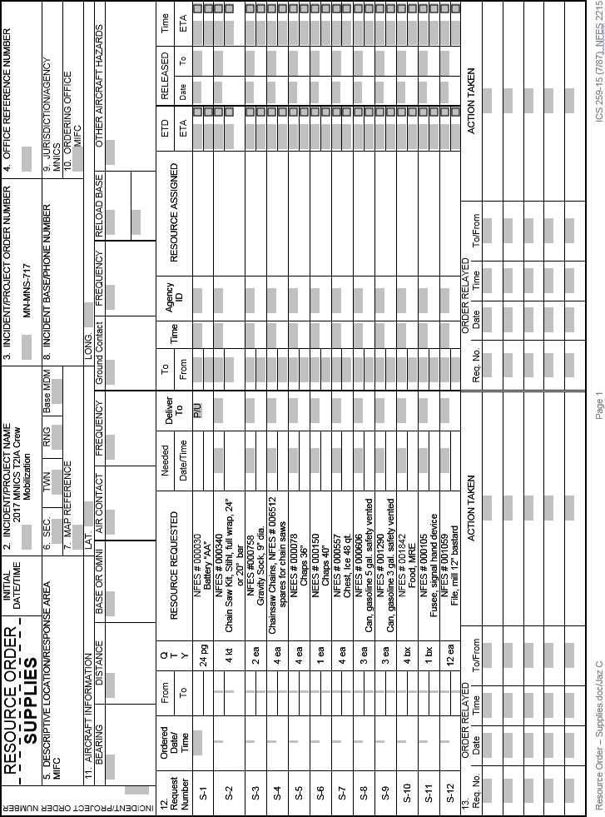
* Correction: S-9 is no longer available. S-15 new NFES# is 0909. In 2026 S-8 will be 0607.

